Microsoft Azure Developer - AZ 204
Create serverless applications
Azure Functions enable the creation of event driven, compute-on-demand systems that can be triggered by various external events

Evaluate Azure services for integration and process automation scenarios

Business processes modeled in software are often called workflows. Azure includes four different technologies that you can use to build and implement workflows that integrate multiple systems:

- Logic Apps
- Microsoft Power Automate
- WebJobs
- Azure Functions

These four technologies

They can all accept inputs.
They can all run actions.
They can all include conditions
They can all produce outputs

Logic Apps is a service within Azure that you can use to automate, orchestrate, and integrate disparate components of a distributed application. By using the design-first approach in Logic Apps, you can draw out complex workflows that model complex business processes. The following screenshot shows the Logic Apps Designer and design canvas that you use to define your workflow.

One reason why Logic Apps is so good at integration is that over 200 connectors are included. A connector is a Logic Apps component that provides an interface to an external service. For example, the Twitter connector allows you to send and retrieve tweets, while the Office 365 Outlook connector lets you manage your email, calendar, and contacts. Logic Apps provides hundreds of pre-built connectors that you can use to create your apps. If you have an unusual or unique system that you want to call from a Logic Apps, you can create your own connector if your system exposes a REST API.

Microsoft Power Automate
Microsoft Power Automate is a service that you can use to create workflows even when you have no development or IT Pro experience. You can create workflows that integrate and orchestrate many different components by using the website or the Microsoft Power Automate mobile app.

As you can see from the following table, Microsoft Power Automate is more appropriate for use by non-technical staff. If your workflow designers are IT professionals, developers, or DevOps practitioners, Logic Apps are usually a better fit:

WebJobs and the WebJobs SDK

The Azure App Service is a cloud-based hosting service for web applications, mobile back-ends, and RESTful APIs. These applications often need to perform some kind of background task. For example, in your bike rental system, when a user uploads a photo of a bike, you may need to generate a smaller thumbnail photograph.
WebJobs are a part of the Azure App Service that you can use to run a program or script automatically. There are two kinds of WebJob:
- Continuous. These WebJobs run in a continuous loop. For example, you could use a continuous WebJob to check a shared folder for a new photo.
- Triggered. These WebJobs run when you manually start them or on a schedule.

Azure Functions

An Azure Function is a simple way for you to run small pieces of code in the cloud, without having to worry about the infrastructure required to host that code. You can write the Function in C#, Java, JavaScript, PowerShell, Python, or any of the languages that are listed in the Supported languages in Azure Functions article. In addition, with the consumption plan option, you only pay for the time when the code runs. Azure automatically scales your function in response to the demand from users.

To create an Azure Function, choose from the range of templates. The following list is an example of some of the templates available to you.

HTTPTrigger , TimerTrigger, BlobTrigger , CosmosDBTrigger

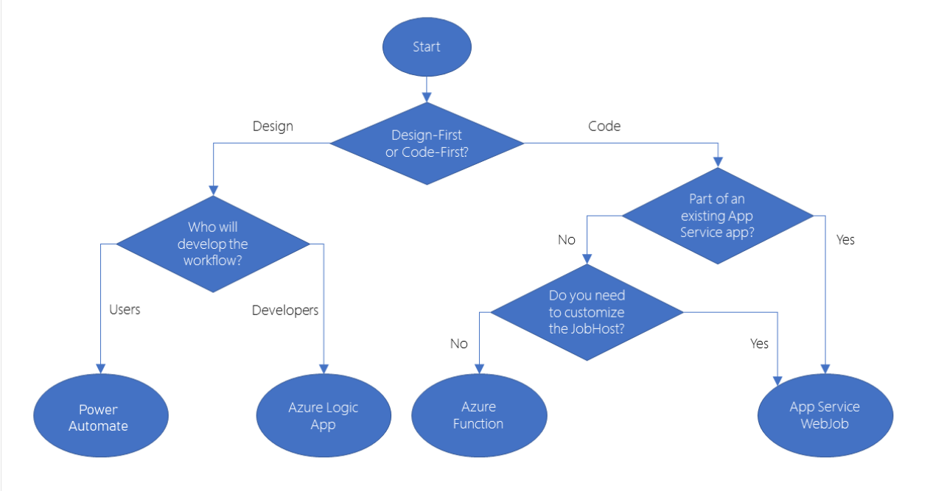

Create serverless logic with Azure Functions

Azure Functions allow developers to host business logic that can be executed without managing or provisioning infrastructure.

Serverless compute can be thought of as a function as a service (FaaS), or a microservice that is hosted on a cloud platform. Your business logic runs as functions and you don't have to manually provision or scale infrastructure. The cloud provider manages infrastructure. Your app is automatically scaled out or down depending on load. Azure has several ways to build this sort of architecture. The two most common approaches are Azure Logic Apps and Azure Functions, which we focus on in this module.

What is Azure Functions?
Azure Functions is a serverless application platform. It allows developers to host business logic that can be executed without provisioning infrastructure. Functions provides intrinsic scalability and you are charged only for the resources used. You can write your function code in the language of your choice, including C#, F#, JavaScript, Python, and PowerShell Core. Support for package managers like NuGet and NPM is also included, so you can use popular libraries in your business logic.

Benefits of a serverless compute solution
Avoids over-allocation of infrastructure
Stateless logic
Event driven

Drawbacks of a serverless compute solution

Execution time
By default, functions have a timeout of 5 minutes. This timeout is configurable to a maximum of 10 minutes. If your function requires more than 10 minutes to execute, you can host it on a VM. Additionally, if your service is initiated through an HTTP request and you expect that value as an HTTP response, the timeout is further restricted to 2.5 minutes. Finally, there's also an option called Durable Functions that allows you to orchestrate the executions of multiple functions without any timeout.

Execution Frequency
The second characteristic is execution frequency. If you expect your function to be executed continuously by multiple clients, it would be prudent to estimate the usage and calculate the cost of using functions accordingly. It might be cheaper to host your service on a VM.

Choose a service plan
Function apps may use one of two types of service plans. The first service plan is the Consumption service plan. This is the plan that you choose when using the Azure serverless application platform. The Consumption service plan provides automatic scaling and bills you when your functions are running. The Consumption plan comes with a configurable timeout period for the execution of a function. By default, it is 5 minutes, but may be configured to have a timeout as long as 10 minutes.
The second plan is called the Azure App Service plan. This plan allows you to avoid timeout periods by having your function run continuously on a VM that you define. When using an App Service plan, you are responsible for managing the app resources the function runs on, so this is technically not a serverless plan. However, it may be a better choice if your functions are used continuously or if your functions require more processing power or execution time than the Consumption plan can provide.

Storage account requirements
When you create a function app, it must be linked to a storage account. You can select an existing account or create a new one. The function app uses this storage account for internal operations such as logging function executions and managing execution triggers. On the Consumption service plan, this is also where the function code and configuration file are stored.
Triggers

Service | Trigger description
Blob Storage | Starts a function when a new or updated blob is detected.
Azure Cosmos DB | Start a function when inserts and updates are detected.
Event Grid | Starts a function when an event is received from Event Grid.
HTTP | Starts a function with an HTTP request.
Microsoft Graph Events | Starts a function in response to an incoming webhook from the Microsoft Graph. Each instance of this trigger can react to one Microsoft Graph resource type.
Queue Storage | Starts a function when a new item is received on a queue. The queue message is provided as input to the function.
Service Bus | Starts a function in response to messages from a Service Bus queue.
Timer | Starts a function on a schedule.

Bindings
Bindings are a declarative way to connect data and services to your function. Bindings know how to talk to different services, which means you don't have to write code in your function to connect to data sources and manage connections. The platform takes care of that complexity for you as part of the binding code. Each binding has a direction - your code reads data from input bindings, and writes data to output bindings. Each function can have zero or more bindings to manage the input and output data processed by the function.

Define a sample binding
Let's look at an example of configuring a function with an input binding (trigger) and an output binding. Let's say we want to write a new row to Azure Table storage whenever a new message appears in Azure Queue Storage. This scenario can be implemented using an Azure Queue Storage trigger and an Azure Table storage output binding.
The following snippet is the function.json file for this scenario.

{
"bindings": [
{
"name": "order",
"type": "queueTrigger",
"direction": "in",
"queueName": "myqueue-items",
"connection": "MY_STORAGE_ACCT_APP_SETTING"
},
{
"name": "$return",
"type": "table",
"direction": "out",
"tableName": "outTable",
"connection": "MY_TABLE_STORAGE_ACCT_APP_SETTING"
}
]
}

Our JSON configuration specifies that our function will be triggered when a message is added to a queue named myqueue-items. The return value of our function is then written to the outTable table in Azure Table storage. For PowerShell functions, output bindings are explicitly written to with the Push-OutputBinding cmdlet.
This example is a simple illustration about how we configure bindings for a function. We could change the output to be an email using a SendGrid binding, or put an event onto a Service Bus to notify some other component in our architecture, or even have multiple output bindings to push data to various services.

Navigate to your function and files
When you create a function from a template, several files are created. For example, if you opted to use the Webhook + API Quickstart using JavaScript, the files generated would be a configuration file, function.json, and a source code file, index.js.

When you select a function in your function app, your function pane appears. To display and edit your code for your function, in the left menu pane, under Developer, select Code + Test. In the function's path above the code box, select function.json from the dropdown list, and then select Test/Run from the top menu bar for the Input/Output pane to appear. See the following screenshot.

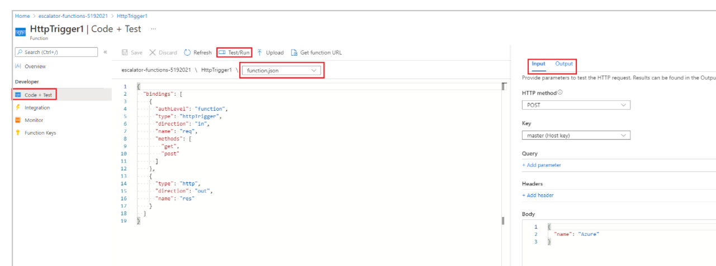

After you've created a function, you'll want to test it. There are a couple of approaches:
- Manual execution
- Testing from within the Azure portal itself

Monitoring and Application Insights dashboard
The ability to monitor your functions is critical during development and in production. The Azure portal provides a monitoring dashboard if you turn on the Application Insights integration. In the left menu pane of your function app, under Monitoring, select Logs and open Application Insights. This Application Insights dashboard provides a quick way to view the history of function executions, and displays the timestamp, result code, duration, and operation ID populated by Application Insights.

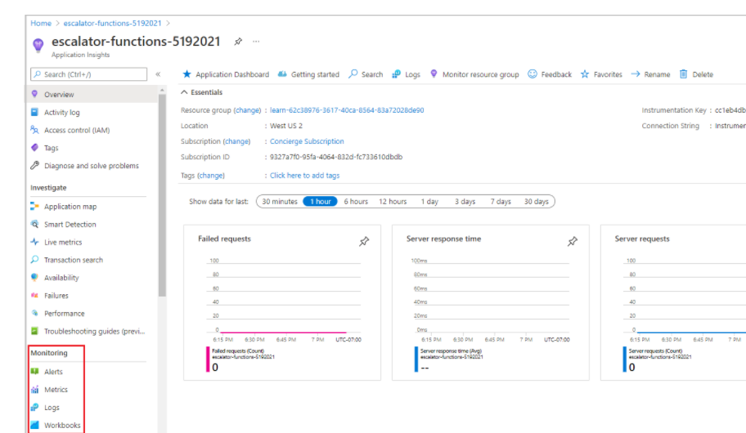

Streaming logs pane
You're also able to add logging statements to your function for debugging in the Azure portal. The called methods for each language are passed a "logging" object, which may be used to log information to the Logs pane located at the bottom of the code window in the Code + Test pane after running a test.
The following JavaScript code snippet shows how to log a message using the context.log method (the context object is passed to the handler).

context.log('Enter your logging statement here'); - javascript
log.Info("Enter your logging statement here");
Write-Host "Enter your logging statement here"

using namespace System.Net

# Input bindings are passed in via param block.
param($Request, $TriggerMetadata)

# Write to the Azure Functions log stream.
Write-Host "PowerShell HTTP trigger function processed a request."

# Interact with query parameters or the body of the request.
$name = $Request.Query.Name
if (-not $name) {
$name = $Request.Body.Name
}

if ($name) {
$status = [HttpStatusCode]::OK
$body = "Hello $name"
}
else {
$status = [HttpStatusCode]::BadRequest
$body = "Please pass a name on the query string or in the request body."
}

# Associate values to output bindings by calling 'Push-OutputBinding'.
Push-OutputBinding -Name Response -Value ([HttpResponseContext]@{
StatusCode = $status
Body = $body
})

Secure HTTP triggers
HTTP triggers let you use API keys to block unknown callers by requiring the key to be present on each request. When you create a function, you select the authorization level. By default, it's set to Function, which requires a function-specific API key, but it can also be set to Admin to use a global "master" key, or Anonymous to indicate that no key is required. You can also change the authorization level through the function properties after creation.
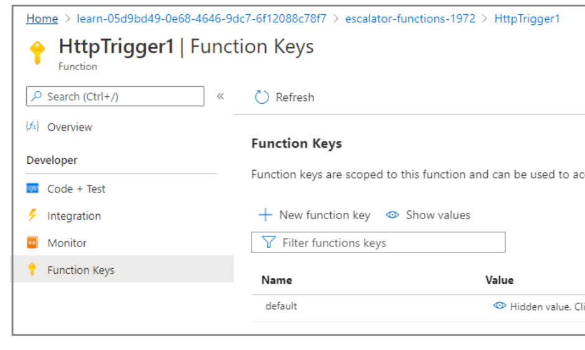

curl --header "Content-Type: application/json" --header "x-functions-key: <your-function-key>" --request POST --data "{\"name\": \"Azure Function\"}" https://<your-url-here>

using namespace System.Net

param($Request, $TriggerMetadata)

Write-Host "Drive Gear Temperature Service triggered"

$readings = $Request.Body.Readings
if ($readings) {
foreach ($reading in $readings) {
if ($reading.temperature -le 25) {
$reading.Status = "OK"
}
elseif ($reading.temperature -le 50) {
$reading.Status = "CAUTION"
}
else {
$reading.Status = "DANGER"
}

Write-Host "Reading is $($reading.Status)"
}

$status = [HttpStatusCode]::OK
$body = $readings
}
else {
$status = [HttpStatusCode]::BadRequest
$body = "Please send an array of readings in the request body"
}

Push-OutputBinding -Name Response -Value ([HttpResponseContext]@{
StatusCode = $status
Body = $body
})

Execute an Azure Function with triggers

An Azure Functions app doesn't do work until something tells it to execute. For example, we could create an Azure Function to send out a reminder text message to our customers before an appointment. If we don't tell the function when it should run, our customers will never receive a message.

What is a binding?
A binding is a connection to data within your function. Bindings are optional and come in the form of input and output bindings. An input binding is the data that your function receives. An output binding is the data that your function sends.
Unlike a trigger, a function can have multiple input and output bindings.

What is a timer trigger?
A timer trigger is a trigger that executes a function at a consistent interval. To create a timer trigger, you need to supply two pieces of information.
- A Timestamp parameter name, which is simply an identifier to access the trigger in code.
- A Schedule, which is a CRON expression that sets the interval for the timer.

0 */5 * * * * - Cron Expression for every 5 minutes
{second} {minute} {hour} {day} {month} {day of the week}

TABLE 1
Setting | Value
Project Details
Subscription | Select the Azure subscription you'd like to use for this exercise
Resource Group | Click the dropdown and use the '[Sandbox resource group name]' resource group
Instance Details
Function App name | <your-webapp-name>
Publish | Code
Runtime stack | .NET
Version | 3.1
Region | select a location close to you

Setting | Value
Storage
Storage account | You can change the name if you like. It will default to a variation of the App name.
Operating system
Operating System | Windows
Plan
Plan type | Consumption (Serverless). When using the Consumption Plan type, you're charged for each execution of your function, and resources are automatically allocated based on your app workload.

Execute an Azure function when a blob is created

What is Azure Storage?
Azure Storage is Microsoft's cloud storage solution that supports all types of data, including: blobs, queues, and NoSQL. The goal of Azure Storage is to provide data storage that's:
- Highly available
- Secure
- Scalable
- Managed

There are three types of blobs: block blobs, append blobs, and page blobs. Block blobs are the most common type. They allow you to store text or binary data efficiently. Append blobs are like block blobs, but they're designed more for append operations like creating a log file that's being constantly updated. Finally, page blobs are made up of pages and are designed for frequent random read and write operations.

samples-workitems/{name}.png

The last significant piece of information with this concept is the text name. The name represents a parameter in your Azure function that receives the name of the added file. For example, if we upload a file named resume.txt, my Azure function receives that value as a string through a parameter called name.

Select Azure Blob Storage trigger.

Chain Azure Functions together using input and output bindings
Azure Functions makes it easy for your function code to integrate with data and services. Through the power of bindings, you declare the data sources to read and write, and let Azure Functions take care of the rest.
- Explore the types of data sources that can be accessed through bindings
- Read data from Azure Cosmos DB by using Azure Functions
- Store data in Azure Cosmos DB by using Azure Functions
- Send messages to Azure Queue Storage by using Azure Functions
Accessing and processing data are key tasks in many software solutions. Consider some of these scenarios:
- You've been asked to implement a way to move incoming data from Azure Blob Storage to Azure Cosmos DB.
- You want to post incoming messages to a queue for processing by another component in your enterprise.
- Your service needs to grab gamer scores from a queue and update an online scoreboard.
There are two kinds of bindings you can use with functions:
- Input binding - Connects to a data source. Our function can read data from these inputs.
- Output binding - Connects to a data destination. Our function can write data to these destinations.

Types of supported bindings
The type of binding defines where we are reading or sending data. There is a binding to respond to web requests and a large selection of bindings to interact directly with various Azure services as well as third-party services.
Some common binding types follow:
- Blob Storage
- Azure Service Bus Queues
- Azure Cosmos DB
- Azure Event Hubs
- External files
- External tables
- HTTP endpoints

Binding properties
Three properties are required in all bindings. You may have to supply additional properties based on the type of binding and storage you are using.
- Name - Defines the function parameter through which you access the data. For example, in a queue input binding, this is the name of the function parameter that receives the queue message content.
- Type - Identifies the type of binding, for example, the type of data or service we want to interact with.
- Direction - Indicates the direction data is flowing, for example, is it an input or output binding?
Additionally, most binding types also need a fourth property:
- Connection - Provides the name of an app setting key that contains the connection string. Bindings use connection strings stored in app settings to keep secrets out of the function code. This makes your code more configurable and secure.

{
"name": "headshotBlob",
"type": "blob",
"path": "thumbnail-images/{filename}",
"connection": "HeadshotStorageConnection",
"direction": "in"
}
{
"bindings": [
{
"authLevel": "function",
"type": "httpTrigger",
"direction": "in",
"name": "Request",
"methods": [
"get",
"post"
]
},
{
"type": "http",
"direction": "out",
"name": "Response"
}
]
}

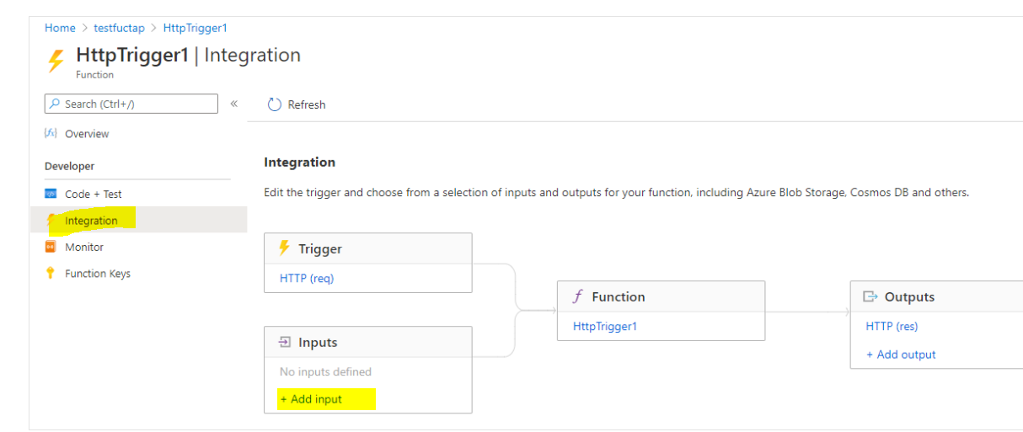
However, the Inputs and Outputs sections of this pane display a plus sign (+) to add more bindings so we can accept more than one input value, and emit more than one output value.
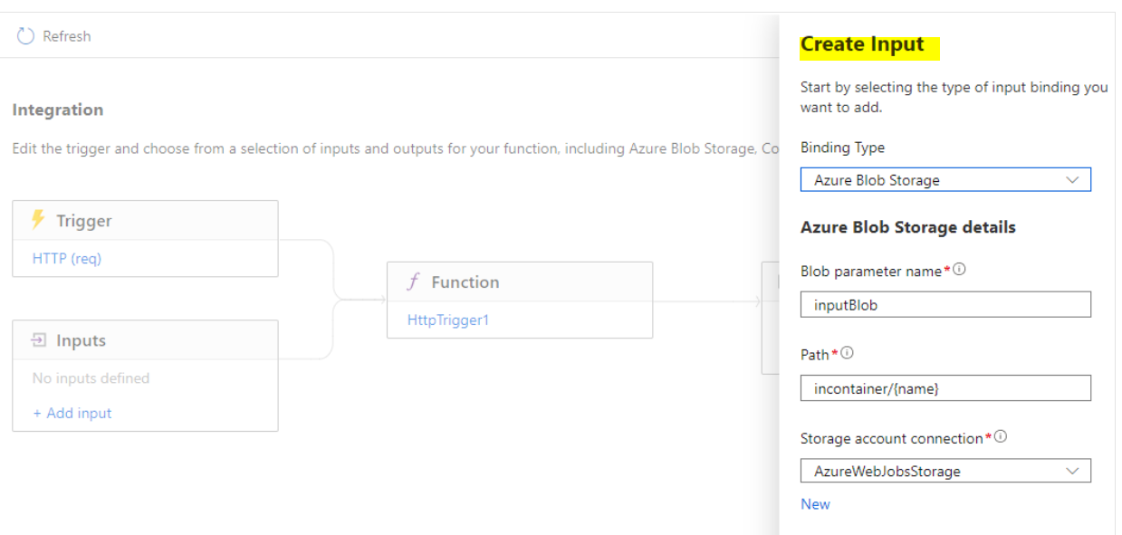

Input binding types
There are multiple types of input. However, not all types support both input and output. You'll use them whenever you want to ingest data of that type. Here, we'll look at the types that support input bindings and when to use them.
- Azure Blob Storage - Blob Storage bindings allow you to read from a blob.
- Azure Cosmos DB - The Azure Cosmos DB input binding uses the SQL API to retrieve one or more Azure Cosmos DB documents and passes them to the input parameter of the function. The document ID or query parameters can be determined based on the trigger that invokes the function.
- Mobile Apps - The Mobile Apps input binding loads a record from a mobile table endpoint and passes it into your function.
- Azure Table storage - You can read data and work with Azure Table storage.

What is a binding expression?
A binding expression is specialized text in function.json, function parameters, or code that is evaluated when the function is invoked to yield a value. For example, if you have a Service Bus Queue binding, you could use a binding expression to get the name of the queue from App Settings.

Types of binding expressions
There are a number of types of binding expressions, including:
- App settings
- Trigger filename
- Trigger metadata
- JSON payloads
- New GUID
- Current date and time
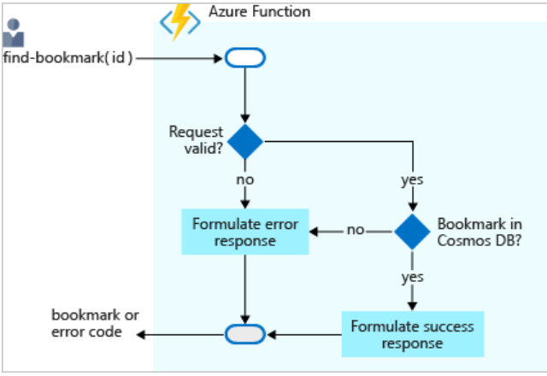
Configuring a binding through the Azure portal is straightforward. As you'll see shortly, you don't have to write code for such tasks, like opening a storage connection. The Azure Functions runtime and bindings take care of those tasks for you.
using namespace System.Net

param($Request, $bookmark, $TriggerMetadata)

if ($bookmark) {
$status = [HttpStatusCode]::OK
$body = @{ url = $bookmark.url }
ContentType = "application/json"
}
else {
$status = [HttpStatusCode]::NotFound
$body = "No bookmarks found"
ContentType = "text/plain"
}

Push-OutputBinding -Name Response -Value ([HttpResponseContext]@{
StatusCode = $status
Body = $body
})
As with input bindings, there are multiple types of output bindings. However, not all types support both input and output. You'll use them anytime you want to send or store data. Here, we'll look at the types that support output bindings and when to use them.

Add an Azure Cosmos DB input binding
Let's repeat what we did in the preceding unit to add an Azure Cosmos DB input binding.
- Ensure your new function, HttpTrigger3, is selected.
- In the left menu pane, under Developer, select Integration. The Integration pane appears for your function.
- To display the list of all possible input binding types, in the Inputs box, select Add input. The Create Input pane appears.
- Under Binding Type, from the dropdown list, select Azure Cosmos DB.
- If a message appears prompting you to install the Microsoft.Azure.WebJobs.Extensions.CosmosDB extension, select install, and wait for it to complete.
- The Azure Cosmos DB account connection setting should be pre-populated with the connection you created in the previous exercise. If you do not see your connection listed, follow these steps to create a new connection.
- To open the Connection window, where you will enter the settings for the new connection, under the Cosmos DB account connection setting, select the New link.
- To create your connection, select OK.
A new connection to the database is configured and appears in the Cosmos DB account connection dropdown list in the Create Input pane.
You want to look up a bookmark with a specific ID, so let's tie an ID that we receive in the query string to the binding.
- In the Document ID setting, enter id.
This syntax is known as a binding expression. The function is triggered by an HTTP request that uses a query string to specify the ID to look up. Because IDs are unique in our collection, the binding will return either 0 (not found) or 1 (found) documents.
- Enter the following remaining values for each setting in this pane. At any time, to learn more about the purpose of each setting, you can select the information icon to its right.
Note
Ensure you enter the following values precisely as documented here:
  - Collection Name = Bookmarks with a capital B
  - Partition key = /id (slash id; NOT curly brackets or any combination of curly brackets and slashes)

Output binding types
- Blob Storage - You can use the blob output binding to write blobs.
- Azure Cosmos DB - The Azure Cosmos DB output binding lets you write a new document to an Azure Cosmos DB database using the SQL API.
- Event Hubs - Use the Event Hubs output binding to write events to an event stream. You must have send permission to an event hub to write events to it.
- HTTP - Use the HTTP output binding to respond to the HTTP request sender. This binding requires an HTTP trigger and allows you to customize the response associated with the trigger's request. This can also be used to connect to webhooks.
- Microsoft Graph - Microsoft Graph output bindings allow you to write to files in OneDrive, modify Excel data, and send email through Outlook.
- Mobile Apps - The Mobile Apps output binding writes a new record to a Mobile Apps table.
- Notification Hubs - You can send push notifications with Notification Hubs output bindings.
- Queue Storage - Use the Azure Queue Storage output binding to write messages to a queue.
- Send Grid - Send emails using SendGrid bindings.
- Service Bus - Use Azure Service Bus output binding to send queue or topic messages.
- Table Storage - Use an Azure Table Storage output binding to write to a table in an Azure Storage account.
- Twilio - Send text messages with Twilio.
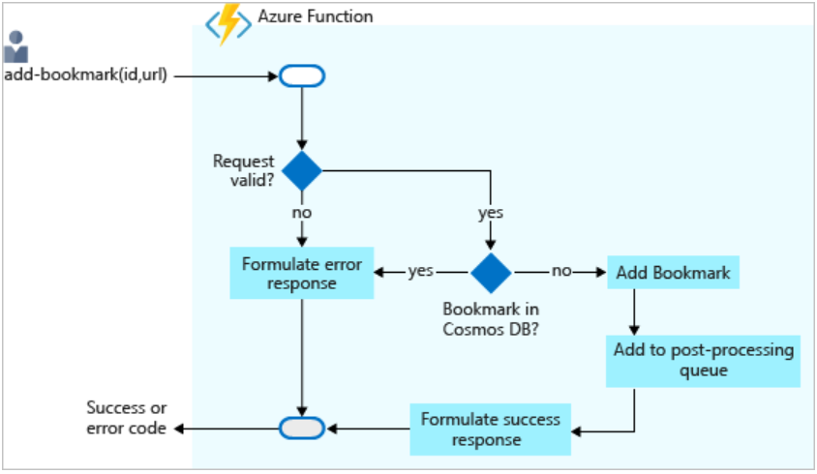

using namespace System.Net

param($Request, $bookmark, $TriggerMetadata)

if ($bookmark) {
$status = 422
$body = "Bookmark already exists."
}
else {
$newBookmark = @{ id = $Request.Body.id; url = $Request.Body.url }

Push-OutputBinding -Name newbookmark -Value $newBookmark

Push-OutputBinding -Name newmessage -Value $newBookmark

$status = [HttpStatusCode]::OK
$body = "bookmark added!"
}

Push-OutputBinding -Name Response -Value ([HttpResponseContext]@{
StatusCode = $status
Body = $body
ContentType = "application/json"
})

Create a long-running serverless workflow with Durable Functions
Durable Functions is an extension of Azure Functions that enables you to perform long-lasting, stateful operations in Azure. Azure provides the infrastructure for maintaining state information. You can use Durable Functions to orchestrate a long-running workflow.

What is Durable Functions?
Durable Functions enables you to implement complex stateful functions in a serverless-environment.
Durable Functions is an extension of Azure Functions. Whereas Azure Functions operate in a stateless environment, Durable Functions can retain state between function calls. This approach enables you to simplify complex stateful executions in a serverless-environment.
Durable Functions is an extension of Azure Functions. Whereas Azure Functions operate in a stateless environment, Durable Functions can retain state between function calls. This approach enables you to simplify complex stateful executions in a serverless-environment.
- They enable you to write event driven code. A durable function can wait asynchronously for one or more external events, and then perform a series of tasks in response to these events.
- You can chain functions together. You can implement common patterns such as fan-out/fan-in, which uses one function to invoke others in parallel, and then accumulate the results.
- You can orchestrate and coordinate functions, and specify the order in which functions should execute.
- The state is managed for you. You don't have to write your own code to save state information for a long-running function.
You can use three durable function types: Client, Orchestrator, and Activity.
Client functions are the entry point for creating an instance of a Durable Functions orchestration.
Orchestrator functions describe how actions are executed, and the order in which they are run.

Activity functions are the basic units of work in a durable function orchestration. Application patterns
Function chaining
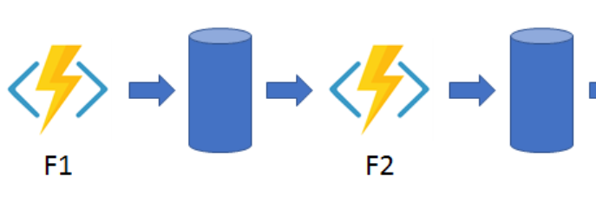

Fan out/fan in - This pattern runs multiple functions in parallel and then waits for all the functions to finish. The results of the parallel executions can be aggregated or used to compute a final result.
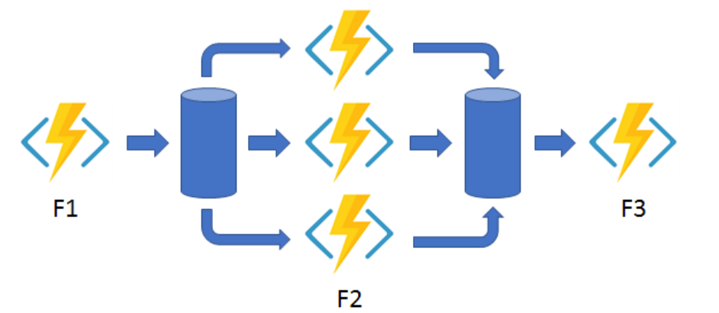
Async HTTP APIs - This pattern addresses the problem of coordinating state of long-running operations with external clients. An HTTP call can trigger the long-running action.
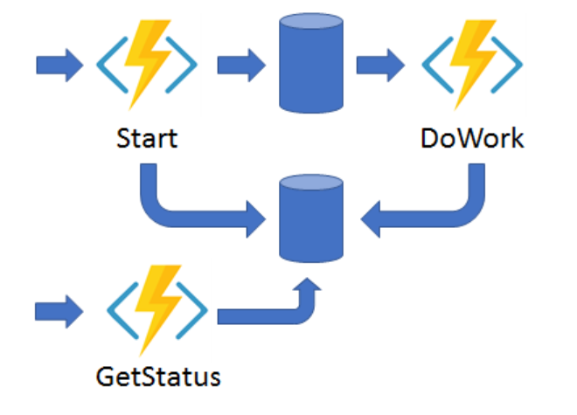
Monitor - This pattern implements a recurring process in a workflow,
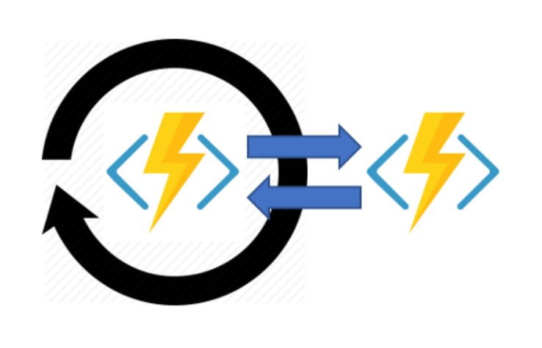
Human interaction - This pattern combines automated processes that also involve some human interaction.
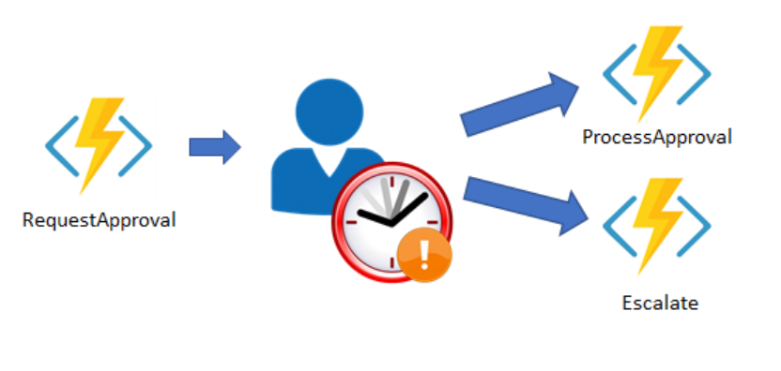

Comparison with Logic Apps
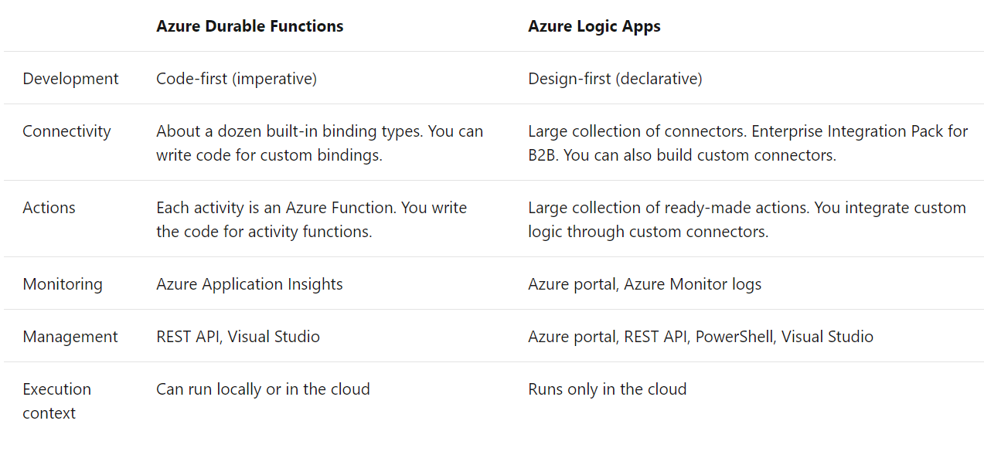
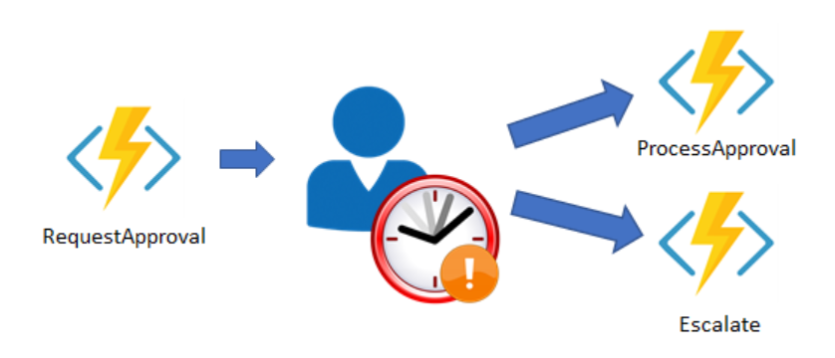
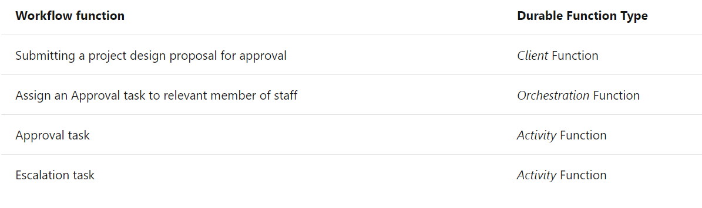
npm install durable-functions

Install the durable-functions npm package

Create the client function for submitting a design proposal

Create the orchestrator function

Create the activity function

Control long-running tasks using timers
When you are working with a long-running workflow, it is important to consider some additional scenarios. For example, what should happen if a task isn't completed within an acceptable period of time? How can you check the status of a task? You can address these concerns with timeouts and escalation paths.

Durable Functions provides timers for use in the orchestrator functions, which you can use to implement delays or set up timeouts for asynchronous actions. You should use durable timers in orchestrator functions instead of the setTimeout() and setInterval() functions.

Using timers for delay

Using timers for timeout

Develop, test, and publish Azure Functions by using Azure Functions Core Tools

The Core Tools feature a variety of functions-related capabilities, but their primary purpose is to:
- Generate the files and folders you need to develop functions on your local computer
- Run your functions locally so you can test and debug them
- Publish your functions to Azure
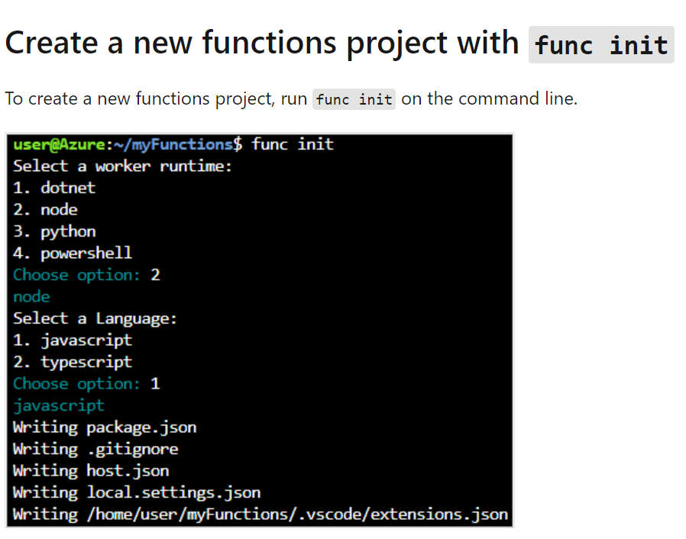

700 XP

Develop, test, and deploy an Azure Function with Visual Studio

Continuous deployment
Continuous deployment is a great option for projects where multiple and frequent contributions are being integrated. It also lets you maintain source control on your functions code. The following deployment sources are currently supported:
- Bitbucket
- Dropbox
- External repository (Git or Mercurial)
- Git local repository
- GitHub
- OneDrive
- Azure DevOps

Zip deployment
az functionapp deployment source config-zip \
-g <resource-group> \
-n <function-app-name> \
--src <zip-file>

Monitor GitHub events by using a webhook with Azure Functions

- Trigger your function with a webhook
- Analyze the message from the webhook
- Secure webhook payloads with a secret

Under Select a template, select HTTP trigger,

Set up a webhook for a GitHub repository

"pages": [
{
"page_name": "Home",
"title": "Home",
"summary": null,
"action": "edited",
"sha": "04d012c5f92a95ae3f7721173bf9f2b1b35ea22f",
"html_url": "https://github.com/.../wiki/Home"
}
],
"repository" : {
"id": 176302421,
"node_id": "MDEwOlJlcG9zaXRvcnkxNzYzMDI0MjE=",
"name": "tieredstorage",
...
},
"sender" : {
...
}

Enable automatic updates in a web application using Azure Functions and SignalR Service

- Implement a function in Azure Functions that runs only when data changes in an Azure Cosmos DB.
- Implement a function in Azure Functions to broadcast changes to connected clients using SignalR Service.
- Update the client web application to respond to SignalR messages.
- Modify a Vue.js and JavaScript web application to use SignalR

{
"bindings": [
{
"type": "httpTrigger",
"authLevel": "anonymous",
"direction": "in",
"name": "req",
"methods": ["get"]
},
{
"type": "http",
"direction": "out",
"name": "res"
},
{
"type": "cosmosDB",
"direction": "in",
"name": "stocks",
"ConnectionStringSetting": "AzureCosmosDBConnectionString",
"databaseName": "stocksdb",
"collectionName": "stocks"
}
]
}

SignalR and persistent connections

SignalR is an abstraction for a series of technologies that allows your app to enjoy two-way communication between the client and server. SignalR handles connection management automatically, and lets you broadcast messages to all connected clients simultaneously, like a chat room. You can also send messages to specific clients. The connection between the client and server is persistent, unlike a classic HTTP connection, which is re-established for each communication.

az signalr create \
--name $SIGNALR_SERVICE_NAME \
--resource-group [sandbox resource group name] \
--sku Free_DS2 \
--unit-count 1

az resource update \
--resource-type Microsoft.SignalRService/SignalR \
--name $SIGNALR_SERVICE_NAME \
--resource-group [sandbox resource group name] \
--set properties.features[flag=ServiceMode].value=Serverless

{
"type": "signalRConnectionInfo",
"name": "connectionInfo",
"hubName": "stocks",
"direction": "in",
"connectionStringSetting": "AzureSignalRConnectionString"
}

{
"type": "cosmosDBTrigger",
"name": "documents",
"direction": "in",
"leaseCollectionName": "leases",
"connectionStringSetting": "AzureCosmosDBConnectionString",
"databaseName": "stocksdb",
"collectionName": "stocks",
"createLeaseCollectionIfNotExists": "true",
"feedPollDelay": 500
}

Set up CORS in the function app

Expose multiple Azure Function apps as a consistent API by using Azure API Management

- Identify the value of Azure API Management in a serverless application
- Import an Azure Functions app as an API in Azure API Management
- Import multiple Azure Functions apps as a single API in Azure API Management

Serverless architecture and microservices
Microservices have become a popular approach to the architecture of distributed applications in recent years. When you build an application as a collection of microservices, you create many different small services. Each service has a defined domain of responsibility, and is developed, deployed, and scaled independently. This modular architecture results in an application that is easier to understand, improve, and test. It also makes continuous delivery easier, because you change only a small part of the whole application when you deploy a microservice.

Azure API Management
Azure API Management (APIM) is a fully managed cloud service that you can use to publish, secure, transform, maintain, and monitor APIs. It helps organizations publish APIs to external, partner, and internal developers to unlock the potential of their data and services. API Management handles all the tasks involved in mediating API calls, including request authentication and authorization, rate limit and quota enforcement, request and response transformation, logging and tracing, and API version management. APIM enables you to create and manage modern API gateways for existing backend services no matter where they are hosted.

APIM Consumption Tier
When you choose a usage plan for API Management, you can choose the consumption tier, because it's especially suited to microservice-based architectures and event-driven systems. For example, it would be a great choice for our online store web API.

Expose function app as an API using Azure API Management
- On the Azure portal menu, or from the Home page, select All resources, and select the Function App whose name begins with ProductFunction.
- In the left nav bar, under the API section, select API Management.
- Under the API Management field, select Create new.

How does API Management help
- Client apps are coupled to the API expressing business logic, not the underlying technical implementation with individual microservices. You can change the location and definition of the services without necessarily reconfiguring or updating the client apps.
- API Management acts as an intermediary. It forwards requests to the right microservice, wherever it is located, and returns responses to users. Users never see the different URIs where microservices are hosted.
- You can use API Management policies to enforce consistent rules on all microservices in the product. For example, you can transform all XML responses into JSON, if that is your preferred format.
- Policies also enable you to enforce consistent security requirements.

2) Connect your services together
Azure lets you create applications composed of various components: web site front-ends, back-end services, and triggered functions that perform compute-on-demand services. Azure also includes various communication strategies to let these various components pass data to each other. Learn how to leverage these communication services to create scalable, efficient solutions out of testable components.
Suppose you work at a software company that develops a music-sharing application. Musicians can upload music they create to your platform by using a web front end or a mobile app. They can listen to and comment on other members' work. The application consists of a website that runs at your ISP, a mobile app that runs on users' mobile devices, a web API that runs in Azure, and an Azure SQL Database where data is stored.
You have observed that at times of high demand, some music files are not successfully uploaded, and some comments are not posted. Your testing shows that these issues are caused by dropped messages between front-end components and the web API. You plan to solve these issues by using one or more of the following technologies: Azure Storage queues, Azure Event Hubs, Azure Event Grid, and Azure Service Bus.
Message Vs Events
Message Contains raw data , Produced by sender , Consumed by receiver
Events Light weight notification , Does not contain raw data , May reference where the data lives ,Sender has no expectations

What is a message?
In the terminology of distributed applications, messages have the following characteristics:
- A message contains raw data, produced by one component, that will be consumed by another component.
- A message contains the data itself, not just a reference to that data.
- The sending component expects the message content to be processed in a certain way by the destination component. The integrity of the overall system may depend on both sender and receiver doing a specific job.

What is an event?
Events are lighter weight than messages, and are most often used for broadcast communications. The components sending the event are known as publishers, and receivers are known as subscribers.
With events, receiving components will generally decide in which communications they are interested, and will "subscribe" to those events. The subscription is managed by an intermediary, like Azure Event Grid or Azure Event Hubs. When publishers send an event, the intermediary will route that event to interested subscribers. This pattern is known as a "publish-subscribe architecture." It's not the only way to deal with events, but it is the most common.
Events have the following characteristics:
- An event is a lightweight notification that indicates that something happened.
- The event may be sent to multiple receivers, or to none at all.
- Events are often intended to "fan out," or have a large number of subscribers for each publisher.
- The publisher of the event has no expectation about the action a receiving component takes.
- Some events are discrete units and unrelated to other events.
- Some events are part of a related and ordered series.

For each communication, consider the following question: Does the sending component expect the communication to be processed in a particular way by the destination component?
If the answer is yes, choose to use a message. If the answer is no, you may be able to use events.

Choose a message-based delivery with queues

- Azure Queue Storage
- Azure Service Bus

What is Azure Queue Storage?
Queue storage is a service that uses Azure Storage to store large numbers of messages that can be securely accessed from anywhere in the world using a simple REST-based interface. Queues can contain millions of messages, limited only by the capacity of the storage account that owns it.

What is Azure Service Bus Queues?
Service Bus is a message broker system intended for enterprise applications. These apps often utilize multiple communication protocols, have different data contracts, higher security requirements, and can include both cloud and on-premises services. Service Bus is built on top of a dedicated messaging infrastructure designed for exactly these scenarios.
Both of these services are based on the idea of a queue, which holds sent messages until the target is ready to receive them.

What are Azure Service Bus Topics?
Azure Service Bus topics are like queues, but can have multiple subscribers. When a message is sent to a topic instead of a queue, multiple components can be triggered to do their work. Imagine in a music-sharing application, a user is listening to a song. The mobile app might send a message to the "Listened" topic. That topic will have a subscription for "UpdateUserListenHistory", and a different subscription for "UpdateArtistsFanList". Each of those functions is handled by a different component that receives its own copy of the message.

Benefits of queues

Increased reliability

Message delivery guarantees
At-Least-Once Delivery: In this approach, each message is guaranteed delivery to at least one of the components that retrieve messages from the queue.
At-Most-Once Delivery: In this approach, each message is not guaranteed for delivery, and there is a small chance that it may not arrive.
First-In-First-Out (FIFO): In most messaging systems, messages usually leave the queue in the same order in which they were added, but you should consider whether this delivery is guaranteed. If your distributed application requires that messages are processed in precisely the correct order, you must choose a queue system that includes a FIFO guarantee.
In this case, we want to make sure all messages get processed, or none of them are processed. We won't be in business long if the credit card message is not delivered, and all our orders are fulfilled without payment! You can avoid these kinds of problems by grouping the two messages into a transaction. Message transactions succeed or fail as a single unit - just like in the database world. If the credit card details message delivery fails, so will the order details message.

Use Service Bus topics if you:
- Need multiple receivers to handle each message

Use Service Bus queues if you:
- Need an At-Most-Once delivery guarantee.
- Need a FIFO guarantee.
- Need to group messages into transactions.
- Want to receive messages without polling the queue.
- Need to provide a role-based access model to the queues.
- Need to handle messages larger than 64 KB but less than 256 KB.
- Queue size will not grow larger than 80 GB.
- Want to publish and consume batches of messages.

Use Queue storage if you:
- Need an audit trail of all messages that pass through the queue.
- Expect the queue to exceed 80 GB in size.
- Want to track progress for processing a message inside of the queue.
A queue is a simple, temporary storage location for messages sent between the components of a distributed application. Use a queue to organize messages and gracefully handle unpredictable surges in demand.

What is Azure Event Grid?
Azure Event Grid is a fully-managed event routing service running on top of Azure Service Fabric. Event Grid distributes events from different sources, such as Azure Blob storage accounts or Azure Media Services, to different handlers, such as Azure Functions or Webhooks. Event Grid was created to make it easier to build event-based and serverless applications on Azure.
Event Grid supports most Azure services as a publisher or subscriber and can be used with third-party services. It provides a dynamically scalable, low-cost, messaging system that allows publishers to notify subscribers about a status change. The following illustration shows Azure Event Grid receiving messages from multiple sources and distributing them to event handlers based on subscription.
There are several concepts in Azure Event Grid that connect a source to a subscriber:
- Events: What happened.
- Event sources: Where the event took place.
- Topics: The endpoint where publishers send events.
- Event subscriptions: The endpoint or built-in mechanism to route events, sometimes to multiple handlers. Subscriptions are also used by handlers to filter incoming events intelligently.
- Event handlers: The app or service reacting to the event.
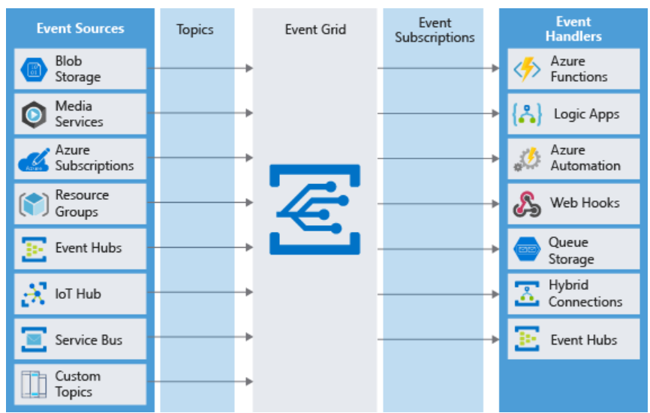

What is an event?
Events are the data messages passing through Event Grid that describe what has taken place. Each event is self-contained, can be up to 64 KB, and contains several pieces of information based on a schema defined by Event Grid:
[
{
"topic": string,
"subject": string,
"id": string,
"eventType": string,
"eventTime": string,
"data":{
object-unique-to-each-publisher
},
"dataVersion": string,
"metadataVersion": string
}
]

Types of event sources
Events can be generated by the following Azure resource types:
- Azure Subscriptions and Resource Groups: Subscriptions and resource groups generate events related to management operations in Azure. For example, when a user creates a virtual machine, this source generates an event.
- Container registry: The Azure Container Registry service generates events when images in the registry are added, removed, or changed.
- Event Hub: Event Hub can be used to process and store events from a variety of data sources - typically logging or telemetry related. Event Hub can generate events to Event Grid when files are captured.
- Service Bus: Service bus can generate events to Event Grid when there are active messages with no active listeners.
- Storage accounts: Storage accounts can generate events when users add blobs, files, table entries, or queue messages. You can use both blob accounts and General-purpose V2 accounts as event sources.
- Media Services: Media Services hosts video and audio media and provides advanced management features for media files. Media Services can generate events when an encoding job is started or completed on a video file.
- Azure IoT Hub: IoT Hub communicates with and gathers telemetry from IoT devices. It can generate events whenever such communications arrive.
- Custom events: Custom events can be generated using the REST API, or with the Azure SDK on Java, GO, .NET, Node, Python, and Ruby. For example, you could create a custom event in the Web Apps feature of Azure App Service. This can happen in the worker role when it picks up a message from a storage queue.

Event handlers
The following object types in Azure can receive and handle events from Event Grid:
- Azure Functions: Custom code that runs in Azure, without the need for explicit configuration of a host virtual server or container. Use an Azure function as an event handler when you want to code a custom response to the event.
- Webhooks: A webhook is a web API that implements a push architecture.
- Azure Logic Apps: An Azure logic app hosts a business process as a workflow.
- Microsoft Power Automate: Flow also hosts workflows, but it is easier for non-technical staff to use.

Should you use Event Grid?
Use Event Grid when you need these features:
- Simplicity: It is straightforward to connect sources to subscribers in Event Grid.
- Advanced filtering: Subscriptions have close control over the events they receive from a topic.
- Fan-out: You can subscribe to an unlimited number of endpoints to the same events and topics.
- Reliability: Event Grid retries event delivery for up to 24 hours for each subscription.
- Pay-per-event: Pay only for the number of events that you transmit.

What is Azure Event Hubs?
Event Hubs is an intermediary for the publish-subscribe communication pattern. Unlike Event Grid, however, it is optimized for extremely high throughput, a large number of publishers, security, and resiliency.
Whereas Event Grid fits perfectly into the publish-subscribe pattern in that it simply manages subscriptions and routes communications to those subscribers, Event Hubs performs quite a few additional services. These additional services make it look more like a service bus or message queue, than a simple event broadcaster.

Partitions
As Event Hubs receives communications, it divides them into partitions.

Capture
Event Hubs can send all your events immediately to Azure Data Lake or Azure Blob storage for inexpensive, permanent persistence.

Authentication
All publishers are authenticated and issued a token. This means Event Hubs can accept events from external devices and mobile apps, without worrying that fraudulent data from pranksters could ruin our analysis.
Choose Event Hubs if:
- You need to support authenticating a large number of publishers.
- You need to save a stream of events to Data Lake or Blob storage.
- You need aggregation or analytics on your event stream.
- You need reliable messaging or resiliency.

Implement message-based communication workflows with Azure Service Bus

Queue
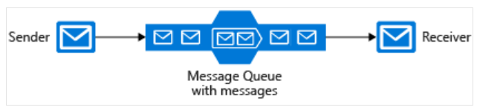
Topic
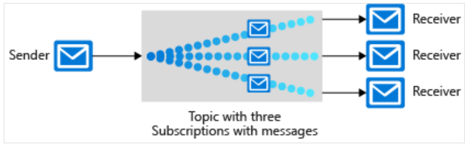

Service Bus queues and storage queues
Key advantages of Service Bus queues include:
- Supports larger messages sizes of 256 KB (standard tier) or 1MB (premium tier) per message versus 64 KB
- Supports both at-most-once and at-least-once delivery - choose between a very small chance that a message is lost or a very small chance it is handled twice
- Guarantees first-in-first-out (FIFO) order - messages are handled in the same order they are added (although FIFO is the normal operation of a queue, it is not guaranteed for every message)
- Can group multiple messages into a transaction - if one message in the transaction fails to be delivered, all messages in the transaction will not be delivered
- Supports role-based security
- Does not require destination components to continuously poll the queue

Exercise - Implement a Service Bus topic and queue

Create a Service Bus namespace
In Azure Service Bus, a namespace is a container, with a unique fully qualified domain name, for queues, topics, and relays. You must start by creating the namespace.
Each namespace has primary and secondary shared access signature encryption keys. To gain access to the objects within the namespace, a sending or receiving component must provide these keys when it connects.

Create a Service Bus queue
To create a Service Bus queue, follow these steps:
- After deployment completes, select Go to resource. The namespace you just created appears.
- In the top menu bar of the namespace pane, select Queue. The Create queue pane appears.
- In the Name text box, enter salesmessages, and then select Create. Azure creates the queue in your namespace.

Create a Service Bus topic and subscriptions
To create a Service Bus topic and subscriptions, follow these steps:
- In the top menu bar of the Service Bus Namespace pane, select Topic. The Create topic pane appears.
- In the Name text box, enter salesperformancemessages, and then select Create. Azure creates the topic in your namespace.
- When the topic has been created, at the bottom of the Service Bus Namespace pane, Queues and Topics tabs appear. Select Topics.
- In the left pane, under Entities, select Topics.
- In the list of topics, select salesperformancemessages.
- Select Subscription to open the Create subscription pane for your first subscription.
- Enter Americas for the Name, then enter 100 for the Max delivery count, and then select Create.
- Select Subscription to open the Create subscription pane for your second subscription.
- Enter EuropeAndAfrica for the Name, and then enter 100 for the Max delivery count, and then select Create.

Write code that uses Service Bus queues

Microsoft.Azure.ServiceBus NuGet package
The most important class in this library for queues is the QueueClient class. You must start by instantiating this class both in sending and receiving components.
using System.Threading;
using System.Threading.Tasks;
using Microsoft.Azure.ServiceBus;
queueClient = new QueueClient(TextAppConnectionString, "PrivateMessageQueue");
string message = "Sure would like a large pepperoni!";
var encodedMessage = new Message(Encoding.UTF8.GetBytes(message));
await queueClient.SendAsync(encodedMessage);

Receive messages from the queue
queueClient.RegisterMessageHandler(MessageHandler, messageHandlerOptions);
await queueClient.CompleteAsync(message.SystemProperties.LockToken);
To access a Service Bus namespace and use a queue, you must configure two pieces of information in your console apps:
- Endpoint for your namespace
- Shared access key for authentication

az servicebus namespace authorization-rule keys list \
--resource-group [sandbox resource group name] \
--name RootManageSharedAccessKey \
--query primaryConnectionString \
--output tsv \
--namespace-name <namespace-name>

using System;
using System.Text;
using System.Threading;
using System.Threading.Tasks;
using Microsoft.Azure.ServiceBus;

namespace privatemessagesender
{
class Program
{
const string ServiceBusConnectionString = "Endpoint=sb://example.servicebus.windows.net/;SharedAccessKeyName=RootManageSharedAccessKey;SharedAccessKey=AbCdEfGhIjKlMnOpQrStUvWxYz==";
const string QueueName = "salesmessages";
static IQueueClient queueClient;

static void Main(string[] args)
{
Console.WriteLine("Sending a message to the Sales Messages queue...");
SendSalesMessageAsync().GetAwaiter().GetResult();
Console.WriteLine("Message was sent successfully.");
}

static async Task SendSalesMessageAsync()
{
queueClient = new QueueClient(ServiceBusConnectionString, QueueName);

try
{
string messageBody = $"$10,000 order for bicycle parts from retailer Adventure Works.";
var message = new Message(Encoding.UTF8.GetBytes(messageBody));
Console.WriteLine($"Sending message: {messageBody}");
await queueClient.SendAsync(message);
}
catch (Exception exception)
{
Console.WriteLine($"{DateTime.Now} :: Exception: {exception.Message}");
}

await queueClient.CloseAsync();
}
}
}
Code to retrieve the message from the queue
using System;
using System.Text;
using System.Threading;
using System.Threading.Tasks;
using Microsoft.Azure.ServiceBus;

namespace privatemessagereceiver
{
class Program
{

const string ServiceBusConnectionString = "Endpoint=sb://example.servicebus.windows.net/;SharedAccessKeyName=RootManageSharedAccessKey;SharedAccessKey=AbCdEfGhIjKlMnOpQrStUvWxYz==";
const string QueueName = "salesmessages";
static IQueueClient queueClient;

static void Main(string[] args)
{

ReceiveSalesMessageAsync().GetAwaiter().GetResult();

}

static async Task ReceiveSalesMessageAsync()
{

queueClient = new QueueClient(ServiceBusConnectionString, QueueName);

Console.WriteLine("======================================================");
Console.WriteLine("Press ENTER key to exit after receiving all the messages.");
Console.WriteLine("======================================================");

RegisterMessageHandler();

Console.Read();

await queueClient.CloseAsync();

}

static void RegisterMessageHandler()
{
var messageHandlerOptions = new MessageHandlerOptions(ExceptionReceivedHandler)
{
MaxConcurrentCalls = 1,
AutoComplete = false
};
queueClient.RegisterMessageHandler(ProcessMessagesAsync, messageHandlerOptions);
}

static async Task ProcessMessagesAsync(Message message, CancellationToken token)
{
Console.WriteLine($"Received message: SequenceNumber:{message.SystemProperties.SequenceNumber} Body:{Encoding.UTF8.GetString(message.Body)}");
await queueClient.CompleteAsync(message.SystemProperties.LockToken);
}

static Task ExceptionReceivedHandler(ExceptionReceivedEventArgs exceptionReceivedEventArgs)
{
Console.WriteLine($"Message handler encountered an exception {exceptionReceivedEventArgs.Exception}.");
var context = exceptionReceivedEventArgs.ExceptionReceivedContext;
Console.WriteLine("Exception context for troubleshooting:");
Console.WriteLine($"- Endpoint: {context.Endpoint}");
Console.WriteLine($"- Entity Path: {context.EntityPath}");
Console.WriteLine($"- Executing Action: {context.Action}");
return Task.CompletedTask;
}
}
}

Write code that uses Service Bus topics

Code with topics versus code with queues
If you want every message sent to be delivered to all subscribing components, you'll use topics. Writing code that uses topics is a way to replace queues. You will use the same Microsoft.Azure.ServiceBus NuGet package, configure connection strings, and use asynchronous programming patterns.
However, you'll use the TopicClient class instead of the QueueClient class to send messages and the SubscriptionClient class to receive messages.

Set filters on subscriptions
Filters can be one of three types:
- Boolean Filters. The TrueFilter ensures that all messages sent to the topic are delivered to the current subscription. The FalseFilter ensures that none of the messages are delivered to the current subscription. (This effectively blocks or switches off the subscription.)
- SQL Filters. A SQL filter specifies a condition by using the same syntax as a WHERE clause in a SQL query. Only messages that return True when evaluated against this subscription will be delivered to the subscribers.
- Correlation Filters. A correlation filter holds a set of conditions that are matched against the properties of each message. If the property in the filter and the property on the message have the same value, it is considered a match.

using System;
using System.Text;
using System.Threading;
using System.Threading.Tasks;
using Microsoft.Azure.ServiceBus;

namespace performancemessagesender
{
class Program
{
const string ServiceBusConnectionString = "Endpoint=sb://example.servicebus.windows.net/;SharedAccessKeyName=RootManageSharedAccessKey;SharedAccessKey=AbCdEfGhIjKlMnOpQrStUvWxYz==";
const string TopicName = "salesperformancemessages";
static ITopicClient topicClient;

static void Main(string[] args)
{
Console.WriteLine("Sending a message to the Sales Performance topic...");
SendPerformanceMessageAsync().GetAwaiter().GetResult();
Console.WriteLine("Message was sent successfully.");
}

static async Task SendPerformanceMessageAsync()
{
topicClient = new TopicClient(ServiceBusConnectionString, TopicName);

try
{
string messageBody = $"Total sales for Brazil in August: $13m.";
var message = new Message(Encoding.UTF8.GetBytes(messageBody));
Console.WriteLine($"Sending message: {messageBody}");
await topicClient.SendAsync(message);
}
catch (Exception exception)
{
Console.WriteLine($"{DateTime.Now} :: Exception: {exception.Message}");
}

await topicClient.CloseAsync();
}
}
}

using System;
using System.Text;
using System.Threading;
using System.Threading.Tasks;
using Microsoft.Azure.ServiceBus;

namespace performancemessagereceiver
{
class Program
{
const string ServiceBusConnectionString = "Endpoint=sb://alexgeddyneil.servicebus.windows.net/;SharedAccessKeyName=RootManageSharedAccessKey;SharedAccessKey=LIWIyxs8baqQ0bRf5zJLef6OTfrv0kBEDxFM/ML37Zs=";
const string TopicName = "salesperformancemessages";
const string SubscriptionName = "Americas";
static ISubscriptionClient subscriptionClient;

static void Main(string[] args)
{
MainAsync().GetAwaiter().GetResult();
}

static async Task MainAsync()
{
subscriptionClient = new SubscriptionClient(ServiceBusConnectionString, TopicName, SubscriptionName);

Console.WriteLine("======================================================");
Console.WriteLine("Press ENTER key to exit after receiving all the messages.");
Console.WriteLine("======================================================");

RegisterMessageHandler();

Console.Read();

await subscriptionClient.CloseAsync();
}

static void RegisterMessageHandler()
{
var messageHandlerOptions = new MessageHandlerOptions(ExceptionReceivedHandler)
{
MaxConcurrentCalls = 1,
AutoComplete = false
};
subscriptionClient.RegisterMessageHandler(ProcessMessagesAsync, messageHandlerOptions);
}

static async Task ProcessMessagesAsync(Message message, CancellationToken token)
{
Console.WriteLine($"Received sale performance message: SequenceNumber:{message.SystemProperties.SequenceNumber} Body:{Encoding.UTF8.GetString(message.Body)}");
await subscriptionClient.CompleteAsync(message.SystemProperties.LockToken);
}

static Task ExceptionReceivedHandler(ExceptionReceivedEventArgs exceptionReceivedEventArgs)
{
Console.WriteLine($"Message handler encountered an exception {exceptionReceivedEventArgs.Exception}.");
var context = exceptionReceivedEventArgs.ExceptionReceivedContext;
Console.WriteLine("Exception context for troubleshooting:");
Console.WriteLine($"- Endpoint: {context.Endpoint}");
Console.WriteLine($"- Entity Path: {context.EntityPath}");
Console.WriteLine($"- Executing Action: {context.Action}");
return Task.CompletedTask;
}
}
}

Communicate between applications with Azure Queue storage

- Create an Azure Storage account that supports queues.
- Create a queue using C# and the Azure Storage Client Library for .NET.
- Add, retrieve, and remove messages from a queue using C# and the Azure Storage Client Library for .NET.

What is Azure Queue storage?
Azure Queue storage is an Azure service that implements cloud-based queues. Each queue maintains a list of messages. Application components access a queue using a REST API or an Azure-supplied client library. Typically, you will have one or more sender components and one or more receiver components. Sender components add messages to the queue. Receiver components retrieve messages from the front of the queue for processing. The following illustration shows multiple sender applications adding messages to the Azure Queue and one receiver application retrieving the messages.
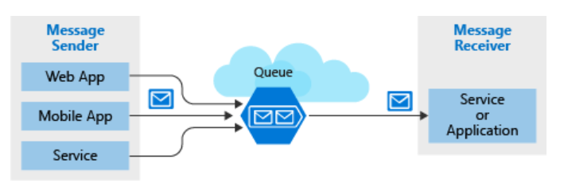

Why use queues?
A queue increases resiliency by temporarily storing waiting messages. At times of low or normal demand, the size of the queue remains small because the destination component removes messages from the queue faster than they are added. At times of high demand, the queue may increase in size, but messages are not lost. The destination component can catch up and empty the queue as demand returns to normal.
A single queue can be up to 500 TB in size, so it can potentially store millions of messages. The target throughput for a single queue is 2000 messages per second, allowing it to handle high-volume scenarios.
Autoscaling responds to demand quickly, but not instantaneously. By contrast, Azure Queue storage instantaneously handles high demand by storing messages until processing resources are available.

What is a message?
A message in a queue is a byte array of up to 64 KB. Message contents are not interpreted at all by any Azure component.
If you want to create a structured message, you could format the message content using XML or JSON. Your code is responsible for generating and interpreting your custom format.

Creating a storage account
A queue must be part of a storage account. You can create a storage account using the Azure CLI (or PowerShell), or Azure portal. The portal is easiest because it's all guided and prompts you for each piece of information.
The following screenshot shows the location of the Storage accounts category.

Creating a storage account
A queue must be part of a storage account. You can create a storage account using the Azure CLI (or PowerShell), or Azure portal. The portal is easiest because it's all guided and prompts you for each piece of information.

Settings for queues
When you create a storage account that will contain queues, you should consider the following settings:
- Queues are only available as part of Azure general-purpose storage accounts (v1 or v2). You cannot add them to Blob storage accounts.
- The Access tier setting which is shown for StorageV2 accounts applies only to Blob storage and does not affect queues.
- You should choose a location that is close to either the source components or destination components or (preferably) both.
- Data is always replicated to multiple servers to guard against disk failures and other hardware problems. You have a choice of replication strategies: Locally Redundant Storage (LRS) is low-cost but vulnerable to disasters that affect an entire data center while Geo-Redundant Storage (GRS) replicates data to other Azure data centers. Choose the replication strategy that meets your redundancy needs.
- The performance tier determines how your messages are stored: Standard uses magnetic drives while Premium uses solid-state drives. Choose Standard if you expect peaks in demand to be short. Consider Premium if queue length sometimes becomes long and you need to minimize the time to access messages.
- Require secure transfer if sensitive information may pass through the queue. This setting ensures that all connections to the queue are encrypted using Secure Sockets Layer (SSL).
az storage account create --name [unique-name] -g [sandbox resource group name] --kind StorageV2 --sku Standard_LRS

Identify a queue
Now that we have a storage account, let's look at how we work with the queue that it will hold.
To access a queue, you need three pieces of information:
- Storage account name
- Queue name
- Authorization token
This information is used by both applications that talk to the queue (the web front end that adds messages and the mid-tier that processes them).

Access authorization
Every request to a queue must be authorized and there are several options to choose from.
ACCESS AUTHORIZATION
Authorization Type | Description
Azure Active Directory | You can use role-based authentication and identify specific clients based on AAD credentials.
Shared Key | Sometimes referred to as an account key, this is an encrypted key signature associated with the storage account. Every storage account has two of these keys that can be passed with each request to authenticate access. Using this approach is like using a root password - it provides full access to the storage account.
Shared access signature | A shared access signature (SAS) is a generated URI that grants limited access to objects in your storage account to clients. You can restrict access to specific resources, permissions, and scope to a data range to automatically turn off access after a period of time.

Retrieving the account key
az storage account keys list --account-name <your storage account name>
Get-AzStorageAccountKey

Using the Azure Storage Client Library for .NET
The Azure Storage Client Library for .NET is a library provided by Microsoft that formulates REST requests and parses REST responses for you. This greatly reduces the amount of code you need to write. Access using the client library still requires the same pieces of information (storage account name, queue name, and account key); however, they are organized differently.
The client library uses a connection string to establish your connection. Your connection string is available in the Settings section of your Storage Account in the Azure portal, or through the Azure CLI and PowerShell.
string connectionString = "DefaultEndpointsProtocol=https;AccountName=<your storage account name>;AccountKey=<your key>;EndpointSuffix=core.windows.net"
az storage account show-connection-string --name <name> --resource-group [sandbox resource group name]
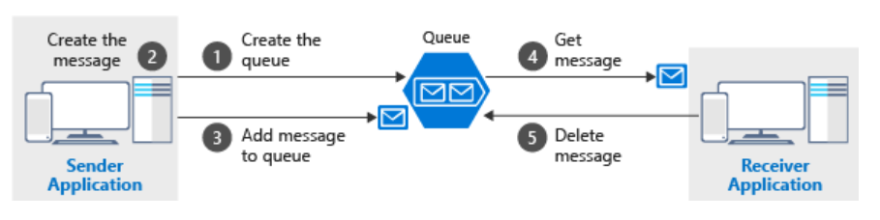
Queues hold messages - packets of data whose shape is known to the sender application and receiver application. The sender creates the queue and adds a message. The receiver retrieves a message, processes it, and then deletes the message from the queue. The following illustration shows a typical flow of this process.

The Azure Storage Client Library for .NET
The Azure Storage Client Library for .NET provides types to represent each of the objects you need to interact with:
- CloudStorageAccount represents your Azure storage account.
- CloudQueueClient represents Azure Queue storage.
- CloudQueue represents one of your queue instances.
- CloudQueueMessage represents a message.

The Azure Storage Client Library for .NET is available in the Azure.Storage.Queues NuGet package.

CloudStorageAccount account = CloudStorageAccount.Parse(connectionString);

CloudQueueClient client = account.CreateCloudQueueClient();

CloudQueue queue = client.GetQueueReference("myqueue");

CloudQueue queue;
//...

await queue.CreateIfNotExistsAsync();

How to send a message
var message = new CloudQueueMessage("your message here");

CloudQueue queue;
//...

await queue.AddMessageAsync(message);

How to receive and delete a message
//...

CloudQueueMessage message = await queue.GetMessageAsync();

if (message != null)
{
// Process the message
//...

await queue.DeleteMessageAsync(message);
}

static async Task SendArticleAsync(string newsMessage)
{
CloudStorageAccount storageAccount = CloudStorageAccount.Parse(ConnectionString);

CloudQueueClient queueClient = storageAccount.CreateCloudQueueClient();

CloudQueue queue = queueClient.GetQueueReference("newsqueue");
bool createdQueue = await queue.CreateIfNotExistsAsync();
if (createdQueue)
{
Console.WriteLine("The queue of news articles was created.");
}

CloudQueueMessage articleMessage = new CloudQueueMessage(newsMessage);
await queue.AddMessageAsync(articleMessage);
}

az storage message peek --queue-name newsqueue --connection-string "<connection-string>"

Retrieve a message from the queue

static async Task<string> ReceiveArticleAsync()
{
CloudQueue queue = GetQueue();
bool exists = await queue.ExistsAsync();
if (exists)
{
CloudQueueMessage retrievedArticle = await queue.GetMessageAsync();
if (retrievedArticle != null)
{
string newsMessage = retrievedArticle.AsString;
await queue.DeleteMessageAsync(retrievedArticle);
return newsMessage;
}
}

return "<queue empty or not created>";
}

static CloudQueue GetQueue()
{
CloudStorageAccount storageAccount = CloudStorageAccount.Parse(ConnectionString);

CloudQueueClient queueClient = storageAccount.CreateCloudQueueClient();
return queueClient.GetQueueReference("newsqueue");
}

Enable reliable messaging for Big Data applications using Azure Event Hubs

- Create an Event Hub using the Azure CLI
- Configure applications to send or receive messages through an Event Hub
- Evaluate Event Hub performance using the Azure portal

What is an Azure Event Hub?
Azure Event Hubs is a cloud-based, event-processing service that can receive and process millions of events per second. Event Hubs acts as a front door for an event pipeline, to receive incoming data and stores this data until processing resources are available.
An entity that sends data to the Event Hubs is called a publisher, and an entity that reads data from the Event Hubs is called a consumer or a subscriber. Azure Event Hubs sits between these two entities to divide the production (from the publisher) and consumption (to a subscriber) of an event stream.
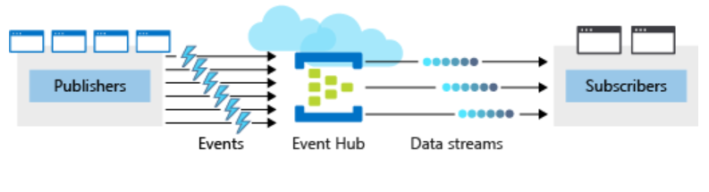

Events
An event is a small packet of information (a datagram) that contains a notification. Events can be published individually, or in batches, but a single publication (individual or batch) can't exceed 1 MB.

Publishers and subscribers
Event publishers are any app or device that can send out events using either HTTPS or Advanced Message Queuing Protocol (AMQP) 1.0.
For publishers that send data frequently, AMQP has better performance. However, it has a higher initial session overhead, because a persistent bidirectional socket and transport-level security (TLS) or SSL/TLS has to be set up first.
For more intermittent publishing, HTTPS is the better option. Though HTTPS requires additional overhead for each request, there isn't the session initialization overhead.
Existing Kafka-based clients, using Apache Kafka 1.0 and newer client versions, can also act as Event Hubs publishers.
Event subscribers are apps that use one of two supported programmatic methods to receive and process events from an Event Hub.
- EventHubReceiver - A simple method that provides limited management options.
- EventProcessorHost - An efficient method that we'll use later in this module.

Consumer groups
An Event Hub consumer group represents a specific view of an Event Hub data stream. By using separate consumer groups, multiple subscriber apps can process an event stream independently, and without affecting other apps. However, the use of many consumer groups isn't a requirement, and for many apps, the single default consumer group is sufficient.

Pricing
There are three pricing tiers for Azure Event Hubs: Basic, Standard, and Dedicated. The tiers differ in terms of supported connections, the number of available Consumer groups, and throughput. When using Azure CLI to create an Event Hubs namespace, if you don't specify a pricing tier, the default of Standard (20 Consumer groups, 1000 Brokered connections) is assigned.

Create and configure new Azure Event Hubs
There are two main steps when creating and configuring new Azure Event Hubs. The first step is to define the Event Hubs namespace. The second step is to create an Event Hub in that namespace.
Keep the following aspects in mind:
- You must balance your configuration against your Azure budget expectations.
- You might consider configuring different Event Hubs for different throughput requirements. For example, if you have a sales data app, and you're planning for two Event Hubs, it would make sense to use a separate namespace for each hub.
az eventhubs namespace
Event Hub name
Partition Count - The number of partitions required in an Event Hub (between 2 and 32). The partition count should be directly related to the expected number of concurrent consumers and can't be changed after the hub has been created.
Message Retention - The number of days (between 1 and 7) that messages will remain available if the data stream needs to be replayed for any reason
az eventhubs eventhub

Configure applications to send or receive messages through an Event Hub

What are the minimum Event Hub application requirements?
To configure an application to send messages to an Event Hub, provide the following information, so that the application can create connection credentials:
- Event Hub namespace name
- Event Hub name
- Shared access policy name
- Primary shared access key
To configure an application to receive messages from an Event Hub, provide the following information, so that the application can create connection credentials:
- Event Hub namespace name
- Event Hub name
- Shared access policy name
- Primary shared access key
- Storage account name
- Storage account connection string
- Storage account container name
storage account create | Create a general-purpose V2 Storage account.
storage account key list | Retrieve the storage account key.
storage account show-connection-string | Retrieve the connection string for an Azure Storage account.
storage container create | Creates a new container in a storage account.
az storage account create --name $STORAGE_NAME --sku Standard_RAGRS --encryption-service blob

Other useful metrics available in the Event Hubs include:
- Throttled Requests: The number of throttled requests because the throughput exceeded unit usage.
- ActiveConnections: The number of active connections on a namespace or Event Hub.
- Incoming/Outgoing Bytes: The number of bytes sent to/received from the Event Hubs service over a specified period.
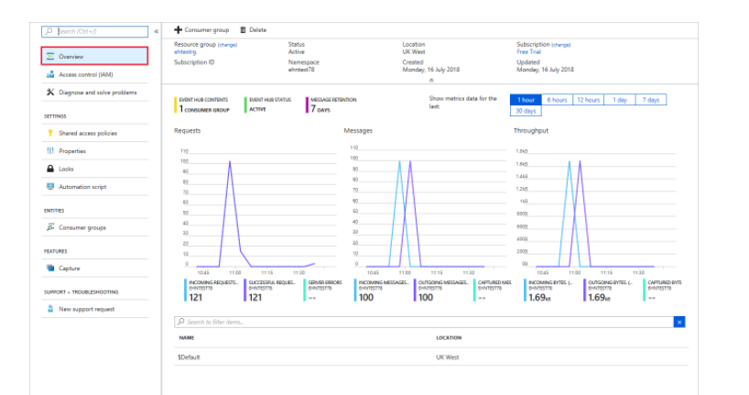

Store data in Azure

Choose a data storage approach in Azure

Classify your data
An online retail business has different types of data. Each type of data may benefit from a different storage solution.
Application data can be classified in one of three ways: structured, semi-structured, and unstructured. Here, you'll learn how to classify your data so that you can choose the appropriate storage solution.

Structured data
Structured data, sometimes referred to as relational data, is data that adheres to a strict schema, so all of the data has the same fields or properties. The shared schema allows this type of data to be easily searched with query languages such as SQL (Structured Query Language). This capability makes this data style perfect for applications such as CRM systems, reservations, and inventory management.

Semi-structured data
Semi-structured data is less organized than structured data, and is not stored in a relational format, as the fields do not neatly fit into tables, rows, and columns. Semi-structured data contains tags that make the organization and hierarchy of the data apparent - for example, key/value pairs. Semi-structured data is also referred to as non-relational or NoSQL data. The expression and structure of the data in this style is defined by a serialization language.
<Person Age="23">
<FirstName>John</FirstName>
<LastName>Smith</LastName>
<Hobbies>
<Hobby Type="Sports">Golf</Hobby>
<Hobby Type="Leisure">Reading</Hobby>
<Hobby Type="Leisure">Guitar</Hobby>
</Hobbies>
</Person>

Unstructured data
The organization of unstructured data is ambiguous. Unstructured data is often delivered in files, such as photos or videos. The video file itself may have an overall structure and come with semi-structured metadata, but the data that comprises the video itself is unstructured. Therefore, photos, videos, and other similar files are classified as unstructured data.

Determine operational needs
- Will you be doing simple lookups using an ID?
- Do you need to query the database for one or more fields?
- How many create, update, and delete operations do you expect?
- Do you need to run complex analytical queries?
- How quickly do these operations need to complete?

What is a transaction?
Here's the question to ask yourself regarding whether you need to use transactions in your application: Will a change to one piece of data in your dataset impact another? If the answer is yes, then you'll need support for transactions in your database service.
Transactions are often defined by a set of four requirements, referred to as ACID guarantees. ACID stands for Atomicity, Consistency, Isolation, and Durability:
- Atomicity means a transaction must execute exactly once and must be atomic; either all of the work is done, or none of it is. Operations within a transaction usually share a common intent and are interdependent.
- Consistency ensures that the data is consistent both before and after the transaction.
- Isolation ensures that one transaction is not impacted by another transaction.
- Durability means that the changes made due to the transaction are permanently saved in the system. Committed data is saved by the system so that even in the event of a failure and system restart, the data is available in its correct state.

OLTP vs OLAP
Transactional databases are often called OLTP (Online Transaction Processing) systems. OLTP systems commonly support lots of users, have quick response times, and handle large volumes of data. They are also highly available (meaning they have very minimal downtime), and typically handle small or relatively simple transactions.
On the contrary, OLAP (Online Analytical Processing) systems commonly support fewer users, have longer response times, can be less available, and typically handle large and complex transactions.

Product catalog data
Data classification: Semi-structured because of the need to extend or modify the schema for new products
Operations:
- Customers require a high number of read operations, with the ability to query many fields within the database.
- The business requires a high number of write operations to track its constantly changing inventory.
Latency & throughput: High throughput and low latency.
Transactional support: Because all of the data is both historical and yet changing, transactional support is required.

Recommended service: Azure Cosmos DB
Azure Cosmos DB supports semi-structured data, or NoSQL data, by design. So, supporting new fields, such as the "Bluetooth-enabled" field or any new fields you need in the future, is a given with Azure Cosmos DB.
Azure Cosmos DB supports SQL for queries and every property is indexed by default. You can create queries so that your customers can filter on any property in the catalog.
Azure Cosmos DB is also ACID-compliant, so you can be assured that your transactions are completed according to those strict requirements.

Why not other Azure services?
Unlike Azure CosmosDB that index every property in the documents, in Azure SQL Database you need to explicitly define what properties from semi-structured documents should be indexed. Azure Cosmos DB is better choice for highly unstructured and variable data where you cannot predict what are the properties that should be indexed.

Photos and videos

Recommended service: Azure Blob storage

Business data
Data classification: Structured
Operations: Read-only, complex analytical queries across multiple databases
Latency & throughput: Some latency in the results is expected based on the complex nature of the queries.
Transactional support: Not required

Recommended service: Azure SQL Database
Business data will most likely be queried by business analysts, who are more likely to know SQL than any other query language. Azure SQL Database could be used as the solution by itself, but pairing it with Azure Analysis Services enables data analysts to create a semantic model over the data in SQL Database. The data analysts can then share it with business users, so that they only need to connect to the model from any business intelligence (BI) tool to immediately explore the data and gain insights

Create an Azure Storage account

What is Azure Storage?
Azure provides many ways to store your data. There are multiple database options like Azure SQL Database, Azure Cosmos DB, and Azure Table Storage. Azure offers multiple ways to store and send messages, such as Azure Queues and Event Hubs. You can even store loose files using services like Azure Files and Azure Blobs.
Azure selected four of these data services and placed them together under the name Azure Storage. The four services are Azure Blobs, Azure Files, Azure Queues, and Azure Tables.
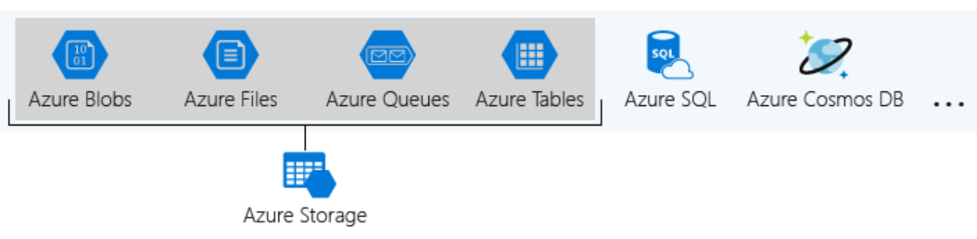

What is a storage account?
A storage account is a container that groups a set of Azure Storage services together. Only data services from Azure Storage can be included in a storage account (Azure Blobs, Azure Files, Azure Queues, and Azure Tables). The following illustration shows a storage account containing several data services.
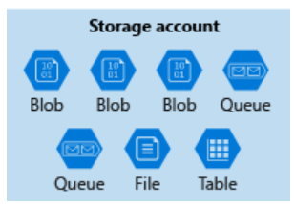
Other Azure data services like Azure SQL and Azure Cosmos DB are managed as independent Azure resources and cannot be included in a storage account.
The settings that are defined by a storage account are:
Subscription , Location , Performance , Replication , Access tier (Hot gives quicker access than Cool, but at increased cost) , Secure transfer required , Virtual networks

Account kind
- StorageV2 (general purpose v2): the current offering that supports all storage types and all of the latest features
- Storage (general purpose v1): a legacy kind that supports all storage types but may not support all features
- Blob storage: a legacy kind that allows only block blobs and append blobs

Storage account Subscription , Resource group , Instance details , Storage account name , Region , Performance , Redundancy - Select Locally redundant storage (LRS) from the dropdown list
Security
Enable secure transfer | Check. This setting controls whether HTTP can be used for the REST APIs used to access data in the storage account. Setting this option to enable forces all clients to use SSL (HTTPS). Most of the time, you'll want to set this to enable as using HTTPS over the network is considered a best practice.
Enable blob public access | Check. We'll allow clients to read data in that container without authorizing the request.
Minimum TLS version | Select Version 1.2 from dropdown list. TLS 1.2 is the most secure version of TLS and is used by Azure Storage on public HTTPS endpoints. TLS 1.1 and 1.0 is supported for backwards compatibility. See Warning at end of table.

Connect an app to Azure Storage
Imagine you're building a photo-sharing application. Every day, thousands of users take pictures, and rely on your application to keep their photos safe while making them accessible across all their devices. Storing these photos is critical to your business, and you want to ensure users that the system used in your application is fast, reliable, and secure. Ideally, this would be done without you having to build all these aspects into the app.
Azure Storage provides such power, resiliency, and performance in the cloud. This module provides instructions about using the power of Azure Storage to achieve the reliability and performance in your app that you require. You can then apply this knowledge to any application.
Durable | Redundancy ensures that your data is safe in the event of transient hardware failures. You can also replicate data across datacenters or geographical regions for extra protection from local catastrophe or natural disaster. Data replicated in this way remains highly available in the event of an unexpected outage.
Secure | All data written to Azure Storage is encrypted by the service. Azure Storage provides you with fine-grained control over who has access to your data.
Scalable | Azure Storage is designed to be massively scalable to meet the data storage and performance needs of today's applications.
Managed | Microsoft Azure handles maintenance and any critical problems for you.

Azure data services
Azure storage includes four types of data:
- Blobs: A massively scalable object store for text and binary data. Can include support for Azure Data Lake Storage Gen2.
- Files: Managed file shares for cloud or on-premises deployments.
- Queues: A messaging store for reliable messaging between application components.
- Table Storage: A NoSQL store for schema-less storage of structured data.

Blob storage
Azure Blob storage is an object storage solution optimized for storing massive amounts of unstructured data, such as text or binary data. Blob storage is ideal for:
- Serving images or documents directly to a browser, including full static websites.
- Storing files for distributed access.
- Streaming video and audio.
- Storing data for backup and restoration, disaster recovery, and archiving.
- Storing data for analysis by an on-premises or Azure-hosted service.
Azure Storage supports three kinds of blobs:
Block blobs | Block blobs are used to hold text or binary files up to ~5 TB (50,000 blocks of 100 MB) in size. The primary use case for block blobs is the storage of files that are read from beginning to end, such as media files or image
Page blobs | Page blobs are used to hold random-access files up to 8 TB in size. Page blobs are used primarily as the backing storage for the VHDs used to provide durable disks for Azure Virtual Machines (Azure VMs).
Append blobs | Append blobs are made up of blocks like block blobs, but they are optimized for append operations.

Files
Azure Files enables you to set up highly available network file shares that can be accessed using the standard Server Message Block (SMB) protocol. This means that multiple VMs can share the same files with both read and write access.
az storage account create \
--resource-group [sandbox resource group name] \
--location eastus \
--sku Standard_LRS \
--name <name>

Interact with the Azure Storage APIs
Azure Storage provides a REST API to work with the containers and data stored in each account. There are independent APIs available to work with each type of data you can store. Recall that we have four specific data types:
- Blobs for unstructured data such as binary and text files.
- Queues for persistent messaging.
- Tables for structured storage of key/values.
- Files for traditional SMB file shares.

Use the REST API
The Storage REST APIs are accessible from anywhere on the Internet, by any app that can send an HTTP/HTTPS request and receive an HTTP/HTTPS response.
For example, if you wanted to list all the blobs in a container, you would send something like:
GET https://[url-for-service-account]/?comp=list&include=metadata

Use a client library
string containerName = "...";
BlobContainerClient container = new BlobContainerClient(connectionString, containerName);

var blobs = container.GetBlobs();
foreach (var blob in blobs)
{
Console.WriteLine($"{blob.Name} --> Created On: {blob.Properties.CreatedOn:YYYY-MM-dd HH:mm:ss} Size: {blob.Properties.ContentLength}");
}
The client libraries are just thin wrappers over the REST API. They are doing exactly what you would do if you used the web services directly. These libraries are also open source, making them very transparent
dotnet add package Azure.Storage.Blobs
To work with data in a storage account, your app will need two pieces of data:
- Access key
- REST API endpoint

Connection strings
The simplest way to handle access keys and endpoint URLs within applications is to use storage account connection strings
Azure Storage connection strings look similar to the following example, but with the access key and account name of your specific storage account:
DefaultEndpointsProtocol=https;AccountName={your-storage};
AccountKey={your-access-key};EndpointSuffix=core.windows.net

Each storage account has two access keys. The reason for this is to allow keys to be rotated (regenerated) periodically as part of security best practice in keeping your storage account secure. This process can be done from the Azure portal or the Azure CLI/PowerShell command line tool.

Shared access signatures (SAS)
Access keys are the easiest approach to authenticating access to a storage account. However they provide full access to anything in the storage account, similar to a root password on a computer.
Storage accounts offer a separate authentication mechanism called shared access signatures that support expiration and limited permissions for scenarios where you need to grant limited access. You should use this approach when you are allowing other users to read and write data to your storage account.
az storage account show-connection-string \
--resource-group [sandbox resource group name] \
--query connectionString \
--name <name>

string blobName = "docs-and-friends-selfie-stick";
string fileName = "docs-and-friends-selfie-stick.png";
BlobClient blobClient = container.GetBlobClient(blobName);
blobClient.Upload(fileName, true);

static void Main(string[] args)
{
var builder = new ConfigurationBuilder()
.SetBasePath(Directory.GetCurrentDirectory())
.AddJsonFile("appsettings.json");

var configuration = builder.Build();

Console.WriteLine("Hello World!");

// Get a connection string to our Azure Storage account.
var connectionString = configuration.GetConnectionString("StorageAccount");

// Get a reference to the container client object so you can create the "photos" container
string containerName = "photos";
BlobContainerClient container = new BlobContainerClient(connectionString, containerName);
container.CreateIfNotExists();

// Uploads the image to Blob storage. If a blb already exists with this name it will be overwritten
string blobName = "docs-and-friends-selfie-stick";
string fileName = "docs-and-friends-selfie-stick.png";
BlobClient blobClient = container.GetBlobClient(blobName);
blobClient.Upload(fileName, true);

// List out all the blobs in the container
var blobs = container.GetBlobs();
foreach (var blob in blobs)
{
Console.WriteLine($"{blob.Name} --> Created On: {blob.Properties.CreatedOn:yyyy-MM-dd HH:mm:ss} Size: {blob.Properties.ContentLength}");
}

Secure your Azure Storage account

Explore Azure Storage security features

After Contoso's competitor has a data breach, Contoso tasks the network administrator to check the organization's data security. As Contoso's data consultant, you assure the network administrator that Azure Storage accounts provide several high-level security benefits for the data in the cloud:
- Protect the data at rest
- Protect the data in transit
- Support browser cross-domain access
- Control who can access data
- Audit storage access

Encryption at rest
All data written to Azure Storage is automatically encrypted by Storage Service Encryption (SSE) with a 256-bit Advanced Encryption Standard (AES) cipher, and is FIPS 140-2 compliant. SSE automatically encrypts data when writing it to Azure Storage. When you read data from Azure Storage, Azure Storage decrypts the data before returning it. This process incurs no additional charges and doesn't degrade performance. It can't be disabled.

Encryption in transit
Keep your data secure by enabling transport-level security between Azure and the client. Always use HTTPS to secure communication over the public internet. When you call the REST APIs to access objects in storage accounts, you can enforce the use of HTTPS by requiring secure transfer for the storage account.

CORS support
Contoso stores several website asset types in Azure Storage. These types include images and videos. To secure browser apps, Contoso locks GET requests down to specific domains.
Azure Storage supports cross-domain access through cross-origin resource sharing (CORS). CORS uses HTTP headers so that a web application at one domain can access resources from a server at a different domain. By using CORS, web apps ensure that they load only authorized content from authorized sources.
CORS support is an optional flag you can enable on Storage accounts. The flag adds the appropriate headers when you use HTTP GET requests to retrieve resources from the Storage account.

Role-based access control
To access data in a storage account, the client makes a request over HTTP or HTTPS. Every request to a secure resource must be authorized. The service ensures that the client has the permissions required to access the data. You can choose from several access options. Arguably, the most flexible option is role-based access.

Auditing access
Auditing is another part of controlling access. You can audit Azure Storage access by using the built-in Storage Analytics service.
Storage Analytics logs every operation in real time, and you can search the Storage Analytics logs for specific requests. Filter based on the authentication mechanism, the success of the operation, or the resource that was accessed.

Storage account keys
In Azure Storage accounts, shared keys are called storage account keys. Azure creates two of these keys (primary and secondary) for each storage account you create. The keys give access to everything in the account.

Protect shared keys
The storage account has only two keys, and they provide full access to the account. Because these keys are powerful, use them only with trusted in-house applications that you control completely.
If the keys are compromised, change the key values in the Azure portal. Here are several reasons to regenerate your storage account keys:
As a best practice, you shouldn't share storage account keys with external third-party applications.
For untrusted clients, use a shared access signature (SAS). A SAS is a string that contains a security token that can be attached to a URI. Use a SAS to delegate access to storage objects and specify constraints, such as the permissions and the time range of access.
You can give a customer a SAS token, for example, so they can upload pictures to a file system in Blob storage. Separately, you can give a web app permission to read those pictures. In both cases, you allow only the access that the application needs to do the task.

Types of shared access signatures
You can use a service-level SAS to allow access to specific resources in a storage account. You'd use this type of SAS, for example, to allow an app to retrieve a list of files in a file system, or to download a file.
Use an account-level SAS to allow access to anything that a service-level SAS can allow, plus additional resources and abilities. For example, you can use an account-level SAS to allow the ability to create file systems.
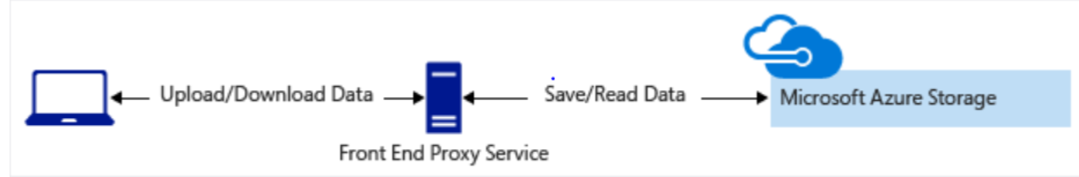
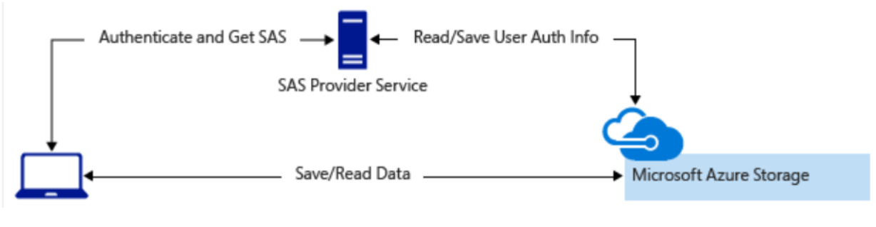
By default, storage accounts accept connections from clients on any network. To limit access to selected networks, you must first change the default action. You can restrict access to specific IP addresses, ranges, or virtual networks.

Manage default network access rules
Manage default network access rules for storage accounts through the Azure portal, PowerShell, or the Azure CLI.
Follow these steps to change default network access in the Azure portal.
- Go to the storage account you want to secure.
- Select Networking.
- To restrict traffic from selected networks, select Selected networks. To allow traffic from all networks, select All networks.
- To apply your changes, select Save.

Understand advanced threat protection for Azure Storage
Azure Defender for Storage provides an extra layer of security intelligence that detects unusual and potentially harmful attempts to access or exploit storage accounts. This layer of protection allows you to address threats without being a security expert or managing security monitoring systems.
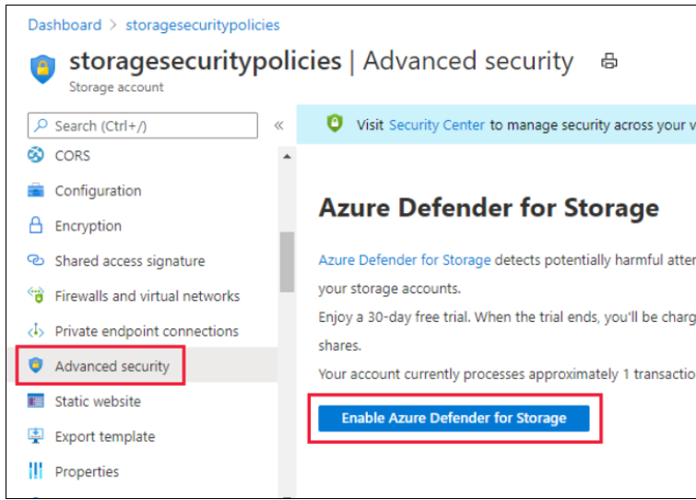
When storage activity anomalies occur, you receive an email notification with information about the suspicious security event. Details of the event include:
- Nature of the anomaly
- Storage account name
- Event time
- Storage type
- Potential causes
- Investigation steps
- Remediation steps
- Email also includes details about possible causes and recommended actions to investigate and mitigate the potential threat

Explore Azure Data Lake Storage security features
Completed100 XP
- 5 minutes
Azure Data Lake Storage Gen2 provides a first-class data lake solution that enables enterprises to consolidate their data. It's built on Azure Blob storage, so it inherits all of the security features we've reviewed in this module.
Along with role-based access control (RBAC), Azure Data Lake Storage Gen2 provides access control lists (ACLs) that are POSIX-compliant, and that restrict access to only authorized users, groups, or service principals. It applies restrictions in a way that's flexible, fine-grained, and manageable. Azure Data Lake Storage Gen2 authenticates through Azure Active Directory OAuth 2.0 bearer tokens. This allows for flexible authentication schemes, including federation with Azure AD Connect and multifactor authentication that provides stronger protection than just passwords.

Store application data with Azure Blob storage

Blobs are used for data storage in many ways across all kinds of apps and architectures:
- Apps that need to transmit large amounts of data using messaging system that supports only small messages. These apps can store data in blobs and send the blob URLs in messages.
- Blob storage can be used like a file system for storing and sharing documents and other personal data.
- Static web assets like images can be stored in blobs and made available for public download as if they were files on a web server.
- Many Azure components use blobs behind the scenes. For example, Azure Cloud Shell stores your files and configuration in blobs, and Azure Virtual Machines uses blobs for hard-disk storage.

Containers
Unlike storage account creation, container creation is a lightweight activity that makes sense to perform from within an app. It's not uncommon for apps to create and delete containers as part of their work.
The following is the typical workflow for apps that use Azure Blob storage:
- Retrieve configuration: At startup, load the storage account configuration. This is typically a storage account connection string.
- Initialize client: To initialize the Azure Storage client library, use the connection string. This creates the objects the app will use to work with the Blob storage API.
- Use: To operate on containers and blobs, make API calls with the client library.

public Task Initialize()
{
CloudStorageAccount storageAccount = CloudStorageAccount.Parse(storageConfig.ConnectionString);
CloudBlobClient blobClient = storageAccount.CreateCloudBlobClient();
CloudBlobContainer container = blobClient.GetContainerReference(storageConfig.FileContainerName);
return container.CreateIfNotExistsAsync();
}
public async Task<IEnumerable<string>> GetNames()
{
List<string> names = new List<string>();

CloudStorageAccount storageAccount = CloudStorageAccount.Parse(storageConfig.ConnectionString);
CloudBlobClient blobClient = storageAccount.CreateCloudBlobClient();
CloudBlobContainer container = blobClient.GetContainerReference(storageConfig.FileContainerName);

BlobContinuationToken continuationToken = null;
BlobResultSegment resultSegment = null;

do
{
resultSegment = await container.ListBlobsSegmentedAsync(continuationToken);

// Get the name of each blob.
names.AddRange(resultSegment.Results.OfType<ICloudBlob>().Select(b => b.Name));

continuationToken = resultSegment.ContinuationToken;
} while (continuationToken != null);

return names;
}
public Task Save(Stream fileStream, string name)
{
CloudStorageAccount storageAccount = CloudStorageAccount.Parse(storageConfig.ConnectionString);
CloudBlobClient blobClient = storageAccount.CreateCloudBlobClient();
CloudBlobContainer container = blobClient.GetContainerReference(storageConfig.FileContainerName);
CloudBlockBlob blockBlob = container.GetBlockBlobReference(name);
return blockBlob.UploadFromStreamAsync(fileStream);
}

public Task<Stream> Load(string name)
{
CloudStorageAccount storageAccount = CloudStorageAccount.Parse(storageConfig.ConnectionString);
CloudBlobClient blobClient = storageAccount.CreateCloudBlobClient();
CloudBlobContainer container = blobClient.GetContainerReference(storageConfig.FileContainerName);
return container.GetBlobReference(name).OpenReadAsync();
}

Deploy a website with Azure virtual machines
- Start with the network
- Name the VM
- Decide the location for the VM
- Determine the size of the VM
- Understanding the pricing model
- Storage for the VM
- Select an operating system

Start with the network
When you set up a virtual network, you specify the available address spaces, subnets, and security. If the VNet will be connected to other VNets, you must select address ranges that are not overlapping. This is the range of private addresses that the VMs and services in your network can use. You can use unroutable IP addresses such as 10.0.0.0/8, 172.16.0.0/12, or 192.168.0.0/16, or define your own range. Azure will treat any address range as part of the private VNet IP address space if it is only reachable within the VNet, within interconnected VNets, and from your on-premises location. If someone else is responsible for the internal networks, you should work with that person before selecting your address space to make sure there is no overlap and to let them know what space you want to use, so they don’t try to use the same range of IP addresses.

Segregate your network
After deciding the virtual network address space(s), you can create one or more subnets for your virtual network. You do this to break up your network into more manageable sections. For example, you might assign 10.1.0.0 to VMs, 10.2.0.0 to back-end services, and 10.3.0.0 to SQL Server VMs.

Secure the network
By default, there is no security boundary between subnets, so services in each of these subnets can talk to one another. However, you can set up Network Security Groups (NSGs), which allow you to control the traffic flow to and from subnets and to and from VMs. NSGs act as software firewalls, applying custom rules to each inbound or outbound request at the network interface and subnet level. This allows you to fully control every network request coming in or out of the VM.

Plan each VM deployment
Once you have mapped out your communication and network requirements, you can start thinking about the VMs you want to create. A good plan is to select a server and take an inventory:
- What does the server communicate with?
- Which ports are open?
- Which OS is used?
- How much disk space is in use?
- What kind of data does this use? Are there restrictions (legal or otherwise) with not having it on-premises?
- What sort of CPU, memory, and disk I/O load does the server have? Is there burst traffic to account for?

Name the VM
One piece of information people often don't put much thought into is the name of the VM. The VM name is used as the computer name, which is configured as part of the operating system. You can specify a name of up to 15 characters on a Windows VM and 64 characters on a Linux VM.
This name also defines a manageable Azure resource, and it's not trivial to change later. That means you should choose names that are meaningful and consistent, so you can easily identify what the VM does. A good convention is to include the following information in the name:
NAME THE VM
Element | Example | Notes
Environment | dev, prod, QA | Identifies the environment for the resource
Location | uw (US West), ue (US East) | Identifies the region into which the resource is deployed
Instance | 01, 02 | For resources that have more than one named instance (web servers, etc.)
Product or Service | service | Identifies the product, application, or service that the resource supports
Role | sql, web, messaging | Identifies the role of the associated resource
For example, devusc-webvm01 might represent the first development web server hosted in the US South Central location.

What is an Azure resource?
An Azure resource is a manageable item in Azure. Just like a physical computer in your datacenter, VMs have several elements that are needed to do their job:
- The VM itself
- Storage account for the disks
- Virtual network (shared with other VMs and services)
- Network interface to communicate on the network
- Network Security Group(s) to secure the network traffic
- Public Internet address (optional)

Decide the location for the VM
Azure has datacenters all over the world filled with servers and disks. These datacenters are grouped into geographic regions ('West US', 'North Europe', 'Southeast Asia', etc.) to provide redundancy and availability.
When you create and deploy a virtual machine, you must select a region where you want the resources (CPU, storage, etc.) to be allocated. This lets you place your VMs as close as possible to your users to improve performance and to meet any legal, compliance, or tax requirements.

Determine the size of the VM
Once you have the name and location set, you need to decide on the size of your VM. Rather than specify processing power, memory, and storage capacity independently, Azure provides different VM sizes that offer variations of these elements in different sizes. Azure provides a wide range of VM size options allowing you to select the appropriate mix of compute, memory, and storage for what you want to do.
The best way to determine the appropriate VM size is to consider the type of workload your VM needs to run. Based on the workload, you're able to choose from a subset of available VM sizes. Workload options are classified as follows on Azure:
DETERMINE THE SIZE OF THE VM
Option | Description
General purpose | General-purpose VMs are designed to have a balanced CPU-to-memory ratio. Ideal for testing and development, small to medium databases, and low to medium traffic web servers.
Compute optimized | Compute optimized VMs are designed to have a high CPU-to-memory ratio. Suitable for medium traffic web servers, network appliances, batch processes, and application servers.
Memory optimized | Memory optimized VMs are designed to have a high memory-to-CPU ratio. Great for relational database servers, medium to large caches, and in-memory analytics.
Storage optimized | Storage optimized VMs are designed to have high disk throughput and IO. Ideal for VMs running databases.
GPU | GPU VMs are specialized virtual machines targeted for heavy graphics rendering and video editing. These VMs are ideal options for model training and inferencing with deep learning.
High performance computes | High performance compute is the fastest and most powerful CPU virtual machines with optional high-throughput network interfaces.
You're able to filter on the workload type when you configure the VM size in the Azure. The size you choose directly affects the cost of your service. The more CPU, memory, and GPU you need, the higher the price point.

What if my size needs change?
Azure allows you to change the VM size when the existing size no longer meets your needs. You can upgrade or downgrade the VM - as long as your current hardware configuration is allowed in the new size. This provides a fully agile and elastic approach to VM management.

Understanding the pricing model
There are two separate costs the subscription will be charged for every VM: compute and storage. By separating these costs, you scale them independently and only pay for what you need.
Compute costs - Compute expenses are priced on a per-hour basis but billed on a per-minute basis. For example, you are only charged for 55 minutes of usage if the VM is deployed for 55 minutes. You are not charged for compute capacity if you stop and deallocate the VM since this releases the hardware. The hourly price varies based on the VM size and OS you select. The cost for a VM includes the charge for the Windows operating system. Linux-based instances are cheaper because there is no operating system license charge.
Tip
You might be able to save money by reusing existing licenses for Windows with the Azure Hybrid benefit.
Storage costs - You are charged separately for the storage the VM uses. The status of the VM has no relation to the storage charges that will be incurred; even if the VM is stopped/deallocated and you aren’t billed for the running VM, you will be charged for the storage used by the disks.
You're able to choose from two payment options for compute costs.
Option | Description
Pay as you go | With the pay-as-you-go option, you pay for compute capacity by the second, with no long-term commitment or upfront payments. You're able to increase or decrease compute capacity on demand as well as start or stop at any time. Prefer this option if you run applications with short-term or unpredictable workloads that cannot be interrupted. For example, if you are doing a quick test, or developing an app in a VM, this would be the appropriate option.
Reserved Virtual Machine Instances | The Reserved Virtual Machine Instances (RI) option is an advance purchase of a virtual machine for one or three years in a specified region. The commitment is made up front, and in return, you get up to 72% price savings compared to pay-as-you-go pricing. RIs are flexible and can easily be exchanged or returned for an early termination fee. Prefer this option if the VM has to run continuously, or you need budget predictability, and you can commit to using the VM for at least a year.

Storage for the VM
Best practice is that all Azure virtual machines will have at least two virtual hard disks (VHDs). The first disk stores the operating system, and the second is used as temporary storage. You can add additional disks to store application data; the maximum number is determined by the VM size selection (typically two per CPU). It's common to create one or more data disks, particularly since the OS disk tends to be quite small. Also, separating out the data to different VHDs allows you to manage the security, reliability, and performance of the disk independently.
The data for each VHD is held in Azure Storage as page blobs, which allows Azure to allocate space only for the storage you use. It's also how your storage cost is measured; you pay for the storage you are consuming.
Option | Description
Unmanaged disks | With unmanaged disks, you are responsible for the storage accounts that are used to hold the VHDs that correspond to your VM disks. You pay the storage account rates for the amount of space you use. A single storage account has a fixed-rate limit of 20,000 I/O operations/sec. This means that a storage account is capable of supporting 40 standard virtual hard disks at full utilization. If you need to scale out with more disks, then you'll need more storage accounts, which can get complicated.
Managed disks | Managed disks are the newer and recommended disk storage model. They elegantly solve this complexity by putting the burden of managing the storage accounts onto Azure. You specify the size of the disk, up to 4 TB, and Azure creates and manages both the disk and the storage. You don't have to worry about storage account limits, which makes managed disks easier to scale out.

Select an operating system
Azure provides a variety of OS images that you can install into the VM, including several versions of Windows and flavors of Linux. As mentioned earlier, the choice of OS will influence your hourly compute pricing as Azure bundles the cost of the OS license into the price.
If you are looking for more than just base OS images, you can search the Azure Marketplace for more sophisticated install images that include the OS and popular software tools installed for specific scenarios. For example, if you needed a new WordPress site, the standard technology stack would consist of a Linux server, Apache web server, a MySQL database, and PHP. Instead of setting up and configuring each component, you can leverage a Marketplace image and install the entire stack all at once.
Finally, if you can't find a suitable OS image, you can create your disk image with what you need, upload it to Azure storage, and use it to create an Azure VM. Keep in mind that Azure only supports 64-bit operating syste

Create a VM using the Azure portal
You've planned out the network infrastructure and identified a few VMs to migrate to the cloud. You have several choices for creating your VMs. The choice you make depends on the environment you're comfortable with. Azure supports a web-based portal for creating and administering resources. You can also choose to use command-line tools that run on Windows, Linux, and macOS.

Azure portal
The Azure portal provides an easy-to-use browser-based user interface that enables you to create and manage all your Azure resources. For example, you can set up a new database, increase the compute power of your virtual machines, and monitor your monthly costs. It's also a great learning tool, because you can survey all available resources and use guided wizards to create the ones you need.
The Azure portal is the easiest way to create resources such as VMs when you are getting started. However, it's not necessarily the most efficient or quickest way to work with Azure, particularly if you need to create several resources together. In our case, we will eventually be creating dozens of VMs to handle different tasks. Creating them manually in the Azure portal wouldn't be a fun task!
Let's look at some other ways to create and administer resources in Azure:
- Azure Resource Manager
- Azure PowerShell
- Azure CLI
- Azure REST API
- Azure Client SDK
- Azure VM Extensions
- Azure Automation Services

Azure Resource Manager
Let's assume you want to create a copy of a VM with the same settings. You could create a VM image, upload it to Azure, and reference it as the basis for your new VM. This process is inefficient and time-consuming. Azure provides you with the option to create a template from which to create an exact copy of a VM.
Typically, your Azure infrastructure will contain many resources, many of them related to one another in some way. For example, the VM we created has the virtual machine itself, storage and network interface. Azure Resource Manager makes working with these related resources more efficient. It organizes resources into named resource groups that let you deploy, update, or delete all of the resources together. When we created the Ubuntu VM site, we identified the resource group as part of the VM creation, and Resource Manager placed the associated resources into the same group.
Resource Manager also enables you to create templates, which can be used to create and deploy specific configurations.

What are Resource Manager templates?
Resource Manager templates are JSON files that define the resources you need to deploy for your solution.
Create resource templates from the Automation section for a specific VM by selecting Export template.
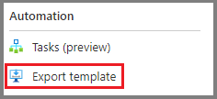
You have the option to save the resource template for later use, or immediately deploy a new VM based on this template. For example, you might create a VM from a template in a test environment, and find it doesn’t quite work to replace your on-premises machine. You can delete the resource group, which deletes all of the resources, tweak the template, and try again. If you only want to make changes to the existing deployed resources, you can change the template used to create it, and deploy it again. Resource Manager will change the resources to match the new template.

Azure PowerShell
Creating administration scripts is a powerful way to optimize your workflow. You can automate everyday, repetitive tasks, and after a script has been verified, it will run consistently, likely reducing errors. Azure PowerShell is ideal for one-off interactive tasks and/or the automation of repeated tasks.
New-AzVm `
-ResourceGroupName "TestResourceGroup" `
-Name "test-wp1-eus-vm" `
-Location "East US" `
-VirtualNetworkName "test-wp1-eus-network" `
-SubnetName "default" `
-SecurityGroupName "test-wp1-eus-nsg" `
-PublicIpAddressName "test-wp1-eus-pubip" `
-OpenPorts 80,3389

Azure CLI
Another option for scripting and command-line Azure interaction is the Azure CLI.
The Azure CLI is Microsoft's cross-platform command-line tool for managing Azure resources such as virtual machines and disks from the command line. It's available for Windows, Linux and macOS, or in the browser using the Cloud Shell. Like Azure PowerShell, the Azure CLI is a powerful way to streamline your administrative workflow. Unlike Azure PowerShell, the Azure CLI does not need PowerShell to function.
az vm create \
--resource-group TestResourceGroup \
--name test-wp1-eus-vm \
--image win2016datacenter \
--admin-username jonc \
--admin-password aReallyGoodPasswordHere

Programmatic (APIs)
Generally speaking, both Azure PowerShell and Azure CLI are good options if you have simple scripts to run and want to stick to command-line tools. When it comes to more complex scenarios, where the creation and management of VMs form part of a larger application with complex logic, another approach is needed.
You can interact with every type of resource in Azure programmatically.

Azure REST API
The Azure REST API provides developers with operations categorized by resource as well as the ability to create and manage VMs. Operations are exposed as URIs with corresponding HTTP methods (GET, PUT, POST, DELETE, and PATCH) and a corresponding response.
The Azure Compute APIs give you programmatic access to virtual machines and their supporting resources. With this API, you have operations to:
- Create and manage availability sets
- Add and manage virtual machine extensions
- Create and manage managed disks, snapshots, and images
- Access the platform images available in Azure
- Retrieve usage information of your resources
- Create and manage virtual machines
- Create and manage virtual machine scale sets

Azure Client SDK
Even though the REST API is platform and language agnostic, most often developers will look toward a higher level of abstraction. The Azure Client SDK encapsulates the Azure REST API, making it much easier for developers to interact with Azure.
The Azure Client SDKs are available for a variety of languages and frameworks, including .NET-based languages such as C#, Java, Node.js, PHP, Python, Ruby, and Go.
Here's an example snippet of C# code to create an Azure VM using the Microsoft.Azure.Management.Fluent NuGet package.
var azure = Azure
.Configure()
.WithLogLevel(HttpLoggingDelegatingHandler.Level.Basic)
.Authenticate(credentials)
.WithDefaultSubscription();
// ...
var vmName = "test-wp1-eus-vm";

azure.VirtualMachines.Define(vmName)
.WithRegion(Region.USEast)
.WithExistingResourceGroup("TestResourceGroup")
.WithExistingPrimaryNetworkInterface(networkInterface)
.WithLatestWindowsImage("MicrosoftWindowsServer", "WindowsServer", "2012-R2-Datacenter")
.WithAdminUsername("jonc")
.WithAdminPassword("aReallyGoodPasswordHere")
.WithComputerName(vmName)
.WithSize(VirtualMachineSizeTypes.StandardDS1)
.Create();

Azure VM extensions
Let's assume you want to configure and install additional software on your virtual machine after the initial deployment. You want this task to use a specific configuration, monitored and executed automatically.
Azure VM extensions are small applications that enable you to configure and automate tasks on Azure VMs after initial deployment. Azure VM extensions can be run with the Azure CLI, PowerShell, Azure Resource Manager templates, and the Azure portal.

Azure Automation services
Saving time, reducing errors, and increasing efficiency are some of the most significant operational management challenges faced when managing remote infrastructure. If you have a lot of infrastructure services, you might want to consider using higher-level services in Azure to help you operate from a higher level.
Azure Automation enables you to integrate services that allow you to automate frequent, time-consuming, and error-prone management tasks with ease. These services include process automation, configuration management, and update management.

Manage the availability of your Azure VMs
Frequently, the success of a services company is directly related to the service level agreements (SLA) the company has with its customers. Your customers expect the services you provide always to be available, and their data kept safe. This is something that Microsoft takes very seriously. Azure provides tools you can use to manage availability, data security, and monitoring, so you know your services are always available for your customers.
To ensure your services aren't interrupted and avoid a single point of failure, it's recommended to deploy at least two instances of each VM. This feature is called an availability set.

What is an availability set?
An availability set is a logical feature used to ensure that a group of related VMs are deployed so that they aren't all subject to a single point of failure and not all upgraded at the same time during a host operating system upgrade in the datacenter. VMs placed in an availability set should perform an identical set of functionalities and have the same software installed.
You can create availability sets through the Azure portal in the disaster recovery section. Also, you can build them using Resource Manager templates, or any of the scripting or API tools. When you place VMs into an availability set, Azure guarantees to spread them across Fault Domains and Update Domains.

What is a fault domain?
A fault domain is a logical group of hardware in Azure that shares a common set of hardware components, and that share a single point of failure. You can think of it as a rack within an on-premises datacenter. The first two VMs in an availability set will be provisioned into two different racks so that if the network or the power failed in a rack, only one VM would be affected. Fault domains are also defined for managed disks attached to VMs.

What is an update domain?
An update domain is a logical group of hardware that can undergo maintenance, or be rebooted at the same time. Azure will automatically place availability sets into update domains to minimize the impact when the Azure platform introduces host operating system changes. Azure then processes each update domain one at a time.
Availability sets are a powerful feature to ensure the services running in your VMs are always available to your customers. However, they aren't foolproof. What if something happens to the data or the software running on the VM itself? For that, we'll need to look at other disaster recovery and backup techniques.

Failover across locations
You can also replicate your infrastructure across sites to handle regional failover. Azure Site Recovery replicates workloads from a primary site to a secondary location. If an outage happens at your primary site, you can fail over to a secondary location. This failover enables users to continue to access your applications without interruption. You can then fail back to the primary location after it's up and running again. Azure Site Recovery is about replication of virtual or physical machines; it keeps your workloads available in an outage.

Back up your virtual machines
Azure Backup is a backup as a service offering that protects physical or virtual machines no matter where they reside: on-premises or in the cloud.
Azure Backup can be used for a wide range of data backup scenarios, such as:
- Files and folders on Windows OS machines (physical or virtual, local or cloud)
- Application-aware snapshots (Volume Shadow Copy Service)
- Popular Microsoft server workloads such as Microsoft SQL Server, Microsoft SharePoint, and Microsoft Exchange
- Native support for Azure Virtual Machines, both Windows, and Linux
- Linux and Windows 10 client machines
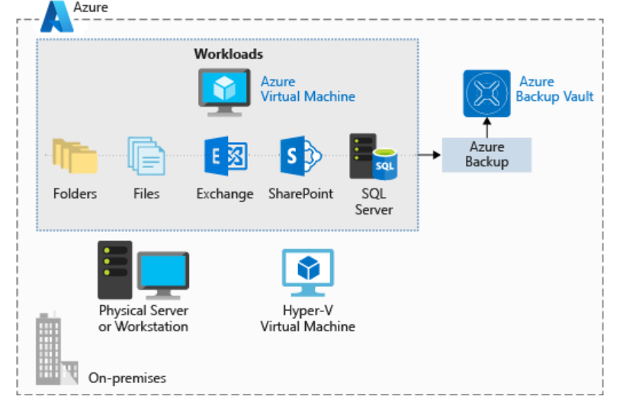

Advantages of using Azure Backup
- Automatic storage management. Azure Backup automatically allocates and manages backup storage and uses a pay-as-you-use model. You only pay for what you use.
- Unlimited scaling. Azure Backup uses the power and scalability of Azure to deliver high availability.
- Multiple storage options. Azure Backup offers locally redundant storage where all copies of the data exist within the same region and geo-redundant storage where your data is replicated to a secondary region.
- Unlimited data transfer. Azure Backup does not limit the amount of inbound or outbound data you transfer. Azure Backup also does not charge for the data that is transferred.
- Data encryption. Data encryption allows for secure transmission and storage of your data in Azure.
- Application-consistent backup. An application-consistent backup means that a recovery point has all required data to restore the backup copy. Azure Backup provides application-consistent backups.
- Long-term retention. Azure doesn't limit the length of time you keep the backup data.

Manage resources in Azure

- Compare each cloud computing deployment model (public, private, and hybrid).
- Understand the advantages of each cloud computing service model.
- Decide which deployment and service model you should use for your services.

Azure solutions for public, private, and hybrid cloud

Public cloud
Public clouds are the most common way of deploying cloud computing. Services are offered over the public internet and available to anyone who wants to purchase them. The cloud resources such as servers and storage are owned and operated by a third-party cloud service provider and delivered over the internet. Services may be free or sold on demand, allowing customers to pay only per usage for the CPU cycles, storage, or bandwidth they consume. Microsoft Azure is an example of a public cloud.

Why public cloud?
- Service consumption through on-demand or subscription model: The on-demand or subscription model allows you to pay for the portion of CPU, storage, and other resources that you use or reserve.
- No up-front investment of hardware: No requirement to purchase, manage, and maintain on-premises hardware and application infrastructure. The cloud service provider is held responsible for all management and maintenance of the system.
- Automation: Quickly provision infrastructure resources using a web portal, scripts, or via automation.
- Geographic dispersity: Store data near your users, or in desired locations without having to maintain your own datacenters.
- Reduced hardware maintenance: The service provider is responsible for hardware maintenance.

Private cloud
A private cloud consists of computing resources used exclusively by users from one business or organization. It can be physically located at your organization’s on-site datacenter, or it can be hosted by a third-party service provider. The term private cloud should not be considered a rebranding of traditional on-premises datacenters. A private cloud uses on-premises infrastructure and services to provide similar benefits of the public cloud. It uses an abstraction platform to provide cloud-like services such as Kubernetes clusters or a complete cloud environment like Azure Stack. The organization is responsible for the purchase, configuration, and maintenance of the hardware. Communication between the systems is usually on the network infrastructure that the business owns and maintains. For example, a private internal network or a dedicated fiber optic connection between buildings.

Why private cloud?
A private cloud can provide more flexibility to an organization. Your organization can customize its cloud environment to meet specific business needs. Since resources are not shared with others, high levels of control and security are possible. Also, private clouds can provide a level of scalability and efficiency.
Examples of why you would use private cloud:
- Pre-existing environment: An existing operating environment that can't be replicated in the public cloud. A large investment in hardware and employees with solution expertise. A large organization may choose to commoditize their computing resources.
- Legacy applications: Business-critical legacy applications that can't easily be physically relocated.
- Data sovereignty and security: Political borders and legal requirements may dictate where data can physically exist.
- Regulatory compliance / certification: PCI or HIPAA compliance. Certified on-premises datacenter.

Hybrid cloud
A hybrid cloud is a computing environment that combines a public cloud and a private cloud by allowing data and applications to be shared between them. When computing and processing demand fluctuates, hybrid cloud computing gives businesses the ability to seamlessly scale their on-premises infrastructure up to the public cloud to handle any overflow - without giving third-party datacenters access to the entirety of their data. Organizations gain the flexibility and computing power of the public cloud for basic and non-sensitive computing tasks, while keeping business-critical applications and data on-premises, safely behind a company firewall.

Why hybrid cloud?
- Existing hardware investment: Business reasons require that you use an existing operating environment and hardware.
- Regulatory requirements: Regulation requires that the data needs to remain at a physical location.
- Unique operating environment: Public cloud can't replicate a legacy operating environment.
- Migration: Move workloads to the cloud over time.

Cloud service models
- Infrastructure-as-a-service (IaaS) provides instant computing infrastructure that you can provision and manage over the Internet.
- Platform as a service (PaaS) provides ready-made development and deployment environments that you can use to deliver your own cloud services.
- Software as a service (SaaS) delivers applications over the Internet as a web-based service.
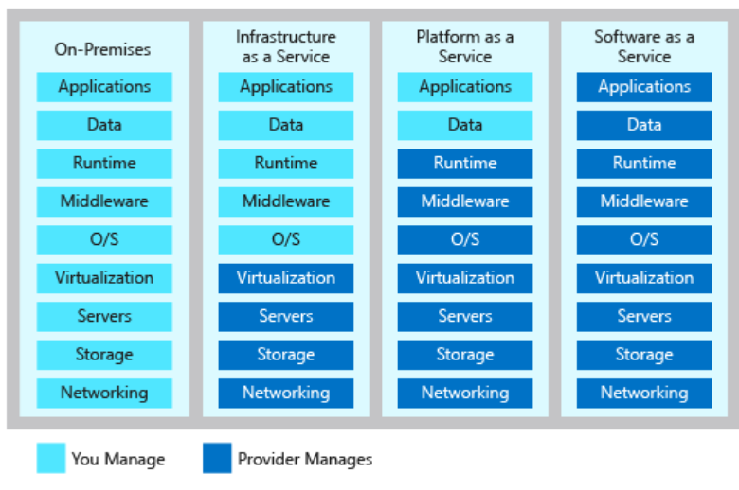

Infrastructure as a service
Completed100 XP
- 4 minutes
Infrastructure as a service (IaaS) is an instant computing infrastructure, provisioned and managed over the Internet. IaaS enables you to quickly scale resources to meet demand and only pay for what you use. IaaS avoids the expense and complexity of buying and managing your own physical servers and other datacenter infrastructure. Each resource is offered as a separate service component, and you rent the resource as long as you need it. As a result, IaaS is flexible. You can provision common infrastructure such as VMs, storage, virtual subnets, firewalls, and VPNs to build a solution. You don't need to manage physical servers and appliances. However, you are responsible for configuring and managing the components. For example, configuring firewalls, updating VM OS's, updating DBMS's, and runtimes.
Website hosting: If you want more control of hosting a website, running websites using IaaS may be a better option than traditional web hosting.
Web apps: IaaS provides all the infrastructure to support web apps, including storage, web and application servers, and networking resources. Organizations can quickly deploy web apps on IaaS and easily scale infrastructure up and down when demand for the apps is unpredictable.
Storage, backup, and recovery: Storage management can be complex, requiring a large capital investment and skilled staff to manage data and meet legal and compliance requirements. IaaS can help simplify planning, management, unpredictable demand, and steadily growing storage needs.
High-performance computing: If you have a workload that requires high-performance computing, you can run the workload in the cloud avoiding the up-front cost of the hardware and only pay for the usage when needed.
Big data analysis: If you have large data sets that contain potentially valuable patterns, trends, and associations, IaaS can provide the processing power to mine data sets to locate patterns.

Advantages
Eliminates capital expense and reduces ongoing cost
Improves business continuity and disaster recovery
Respond quicker to shifting business conditions
Increase stability, reliability, and supportability

Platform as a service
Platform as a service (PaaS) is a complete development and deployment environment in the cloud. With PaaS, you can build and deploy everything from simple cloud-based apps to sophisticated, cloud-enabled enterprise applications. You purchase the resources from a cloud service provider on a pay-as-you-go basis and access them over a secure Internet connection. Like IaaS, PaaS includes infrastructure such as servers, storage, and networking. In addition, it also includes middleware, development tools, and other services. PaaS supports the complete web application lifecycle: building, testing, deploying, managing, and updating. PaaS removes the need to manage software licenses, middleware, and infrastructure of the services. You manage the applications and services you develop, and the cloud service provider typically manages everything else.

Advantages
Reduced development time
Develop for multiple platforms
Use sophisticated tools affordably
Support geographically distributed development teams
Efficiently manage the application lifecycle

Software as a service

Software as a service (SaaS) allows users to connect to and use cloud-based apps over the Internet. Common examples are email, calendaring, and office tools such as Microsoft 365. SaaS provides a complete software solution that you purchase on a pay-as-you-go basis from a cloud service provider. You can rent the use of an application for your organization. Your users connect to the service over the Internet, usually with a web browser. All of the underlying infrastructure, middleware, app software, and app data are located in the service provider’s data center. The service provider manages the hardware and software, and with the appropriate service agreement, will ensure the availability and the security of the app and your data as well. SaaS allows your organization to get quickly up and running with an app at minimal upfront cost.

Advantages
Gain access to sophisticated applications
Use free client software
Access app data from anywhere

Control Azure services with the CLI

What is the Azure CLI?

The Azure CLI is a command-line program to connect to Azure and execute administrative commands on Azure resources. It runs on Linux, macOS, and Windows and allows administrators and developers to execute their commands through a terminal or command-line prompt (or script!) instead of a web browser.

az vm restart -g MyResourceGroup -n MyVm

Azure CLICopy
variable="value"
variable=integer

PowerShellCopy
$variable="value"
$variable=integer

The Azure CLI lets you control nearly every aspect of every Azure resource. You can work with resource groups, storage, virtual machines, Azure Active Directory (Azure AD), containers, machine learning, and so on.
az find blob
az find "az vm"
az find "az vm create"
az storage blob --help
az login
az group create --name <name> --location <location>
az group list
az group list --output table
az appservice plan create --name $AZURE_APP_PLAN --resource-group $RESOURCE_GROUP --location $AZURE_REGION --sku FREE
az appservice plan list --output table
az webapp create --name $AZURE_WEB_APP --resource-group $RESOURCE_GROUP --plan $AZURE_APP_PLAN
az webapp deployment source config --name $AZURE_WEB_APP --resource-group $RESOURCE_GROUP --repo-url "https://github.com/Azure-Samples/php-docs-hello-world" --branch master --manual-integration
The Azure CLI is a good choice for anyone new to Azure command line and scripting. Its simple syntax and cross-platform compatibility help reduce the risk of errors when performing regular and repetitive tasks.

Automate Azure tasks using scripts with PowerShell

Decide if Azure PowerShell is right for your tasks

What is Azure PowerShell?
Azure PowerShell is a module that you add to Windows PowerShell or PowerShell Core to let you connect to your Azure subscription and manage resources. Azure PowerShell requires PowerShell to function. PowerShell provides services like the shell window, command parsing, and so on. Azure PowerShell adds the Azure-specific commands.
For example, Azure PowerShell provides the New-AzVM command that creates a virtual machine for you inside your Azure subscription.

How to Choose an administrative tool
Automation
Learning curve
Team skillset

Install PowerShell

Suppose you have chosen Azure PowerShell as your automation solution. Your administrators prefer to run their scripts locally rather than in the Azure Cloud Shell. The team uses machines that run Linux, macOS, and Windows. You need to get Azure PowerShell working on all their devices.

- The base PowerShell product This comes in two variants: PowerShell on Windows, and PowerShell Core on macOS and Linux.
- The Azure PowerShell module This extra module must be installed to add the Azure-specific commands to PowerShell.

Cmdlets follow a verb-noun naming convention; for example, Get-Process, Format-Table, and Start-Service. There is also a convention for verb choice: "get" toSelect-AzSubscription -SubscriptionId '53dde41e-916f-49f8-8108-558036f826ae' retrieve data, "set" to insert or update data, "format" to format data, "out" to direct output to a destination, and so on.

Get-Help Get-ChildItem -detailed
Install-Module -Name Az -AllowClobber -SkipPublisherCheck
Update-Module -Name Az

Get-AzResourceGroup
New-AzResourceGroup -Name <name> -Location <location>
New-AzVm
-ResourceGroupName <resource group name>
-Name <machine name>
-Credential <credentials object>
-Location <location>
-Image <image name>
Stop-AzVM -Name $vm.Name -ResourceGroup $vm.ResourceGroupName

Plan and manage your Azure costs

- Use the Total Cost of Ownership Calculator to compare your current datacenter costs to running the same workloads on Azure.
- Describe the different ways you can purchase Azure products and services.
- Use the Pricing calculator to estimate the monthly cost of running your cloud workloads.
- Define some of the major factors that affect total cost and apply recommended practices to minimize cost.

Compare costs by using the Total Cost of Ownership Calculator

Working with the TCO Calculator involves three steps:
- Define your workloads.
- Adjust assumptions.
- View the report.

Step 1: Define your workloads
First, you enter the specifications of your on-premises infrastructure into the TCO Calculator, based on these four categories:
- Servers
This category includes operating systems, virtualization methods, CPU cores, and memory (RAM).
- Databases
This category includes database types, server hardware, and the Azure service you want to use, which includes the expected maximum concurrent user sign-ins.
- Storage
This category includes storage type and capacity, which includes any backup or archive storage.
- Networking
This category includes the amount of network bandwidth you currently consume in your on-premises environment.

Step 2: Adjust assumptions
Next, you specify whether your current on-premises licenses are enrolled for Software Assurance, which can save you money by reusing those licenses on Azure. You also specify whether you need to replicate your storage to another Azure region for greater redundancy.
Then, you can see the key operating cost assumptions across several different areas, which vary among teams and organizations. These costs have been certified by Nucleus Research, an independent research company. For example, these costs include:
- Electricity price per kilowatt hour (KWh).
- Hourly pay rate for IT administration.
- Network maintenance cost as a percentage of network hardware and software costs.
To improve the accuracy of the TCO Calculator results, you adjust the values so that they match the costs of your current on-premises infrastructure.

Step 3: View the report
Choose a time frame between one and five years. the TCO Calculator generates a report that's based on the information you've entered. Here's an example:
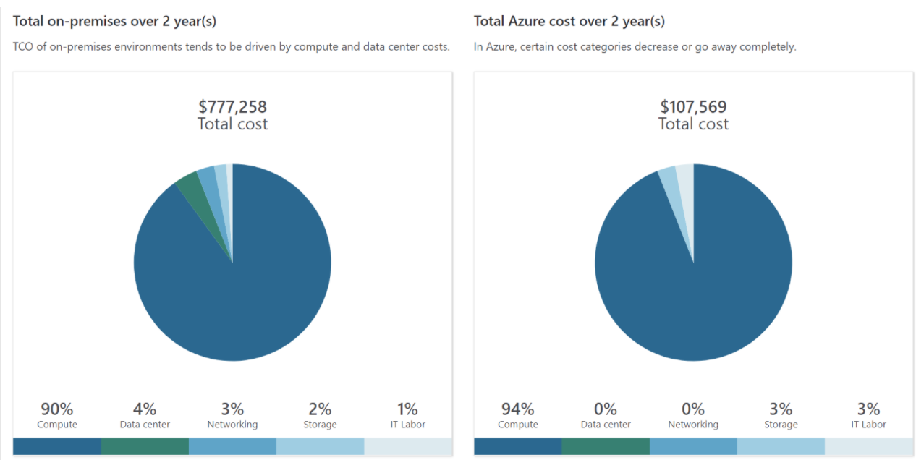

Exercise - Compare sample workload costs by using the TCO Calculator

In this exercise, you use the Total Cost of Ownership (TCO) Calculator to compare the cost of running a sample workload in the datacenter versus on Azure.

Let's say that:
- Tailwind Traders runs two sets, or banks, of 50 virtual machines (VMs) in each bank.
- The first bank of VMs runs Windows Server under Hyper-V virtualization.
- The second bank of VMs runs Linux under VMware virtualization.
- There's also a storage area network (SAN) with 60 terabytes (TB) of disk storage.
- You consume an estimated 15 TB of outbound network bandwidth each month.
- There are also a number of databases involved, but for now, you'll omit those details.

Purchase Azure services

- What types of Azure subscriptions are available?
- How do we purchase Azure services?
- Does location or network traffic affect cost?
- What other factors affect the final cost?
- How can we get a more detailed estimate of the cost to run on Azure?

How do I purchase Azure services?

There are three main ways to purchase services on Azure. They are:
- Through an Enterprise Agreement
Larger customers, known as enterprise customers, can sign an Enterprise Agreement with Microsoft. This agreement commits them to spending a predetermined amount on Azure services over a period of three years. The service fee is typically paid annually. As an Enterprise Agreement customer, you'll receive the best customized pricing based on the kinds and amounts of services you plan on using.
- Directly from the web
Here, you purchase Azure services directly from the Azure portal website and pay standard prices. You're billed monthly, as a credit card payment or through an invoice. This purchasing method is known as Web Direct.
- Through a Cloud Solution Provider
A Cloud Solution Provider (CSP) is a Microsoft Partner who helps you build solutions on top of Azure. Your CSP bills you for your Azure usage at a price they determine. They also answer your support questions and escalate them to Microsoft, as needed.

What factors affect cost?

Resource type

Usage meters
Let's look at a single VM as an example. The following kinds of meters are relevant to tracking its usage:
- Overall CPU time.
- Time spent with a public IP address.
- Incoming (ingress) and outgoing (egress) network traffic in and out of the VM.
- Disk size and amount of disk read and disk write operations.

Resource usage
In Azure, you're always charged based on what you use. As an example, let's look at how this billing applies to deallocating a VM.
In Azure, you can delete or deallocate a VM. Deleting a VM means that you no longer need it. The VM is removed from your subscription, and then it's prepared for another customer.
Deallocating a VM means that the VM is no longer running. But the associated hard disks and data are still kept in Azure. The VM isn't assigned to a CPU or network in Azure's datacenter, so it doesn't generate the costs associated with compute time or the VM's IP address. Because the disks and data are still stored, and the resource is present in your Azure subscription, you're still billed for disk storage.

Azure subscription types
Some Azure subscription types also include usage allowances, which affect costs.

Azure Marketplace
You can also purchase Azure-based solutions and services from third-party vendors through Azure Marketplace. Examples include managed network firewall appliances or connectors to third-party backup services. Billing structures are set by the vendor.

Does location or network traffic affect cost?
When you provision a resource in Azure, you need to define the location (known as the Azure region) of where it will be deployed. Let's see why this decision can have cost consequences.

Location
Azure infrastructure is distributed globally, which enables you to deploy your services centrally or provision your services closest to where your customers use them.
Different regions can have different associated prices. Because geographic regions can impact where your network traffic flows, network traffic is a cost influence to consider as well.

Zones for billing of network traffic
Billing zones are a factor in determining the cost of some Azure services.

How can I estimate the total cost?
As you've learned, an accurate cost estimate takes all of the preceding factors into account. Fortunately, the Azure Pricing calculator helps you with that process.
The Pricing calculator displays Azure products in categories. You add these categories to your estimate and configure according to your specific requirements. You then receive a consolidated estimated price, with a detailed breakdown of the costs associated with each resource you added to your solution. You can export or share that estimate or save it for later. You can load a saved estimate and modify it to match updated requirements.
You also can access pricing details, product details, and documentation for each product from within the Pricing calculator.

Estimate workload cost by using the Pricing calculator

Define your requirements

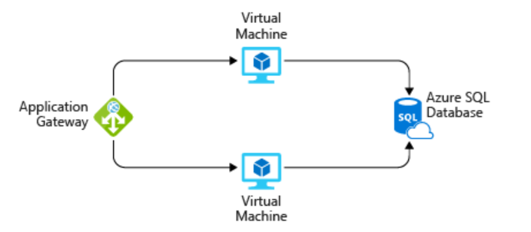

Manage and minimize total cost on Azure

Calculate your projected costs by using the Pricing calculator and the Total Cost of Ownership (TCO) Calculator. Only add the products, services, and resources that you need for your solution.

Use Azure Advisor to monitor your usage
Ideally, you want your provisioned resources to match your actual usage.
Azure Advisor identifies unused or underutilized resources and recommends unused resources that you can remove. This information helps you configure your resources to match your actual workload.
The following image shows some example recommendations from Azure Advisor:
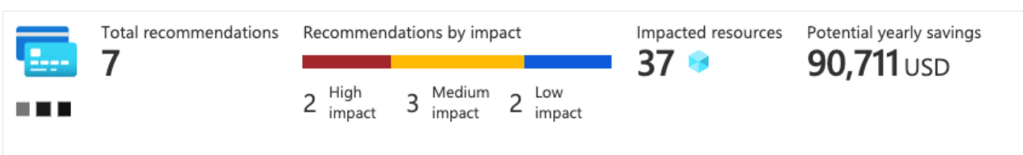

Use spending limits to restrict your spending
If you have a free trial or a credit-based Azure subscription, you can use spending limits to prevent accidental overrun.

Use Azure Reservations to prepay
Azure Reservations offers discounted prices on certain Azure services. Azure Reservations can save you up to 72 percent as compared to pay-as-you-go prices. To receive a discount, you reserve services and resources by paying in advance.
For example, you can prepay for one year or three years of use of VMs, database compute capacity, database throughput, and other Azure resources.
The following example shows estimated savings on VMs. In this example, you save an estimated 72 percent by committing to a three-year term.

Choose low-cost locations and regions
The cost of Azure products, services, and resources can vary across locations and regions. If possible, you should use them in those locations and regions where they cost less.

Research available cost-saving offers
Keep up to date with the latest Azure customer and subscription offers, and switch to offers that provide the greatest cost-saving benefit.

Use Azure Cost Management + Billing to control spending
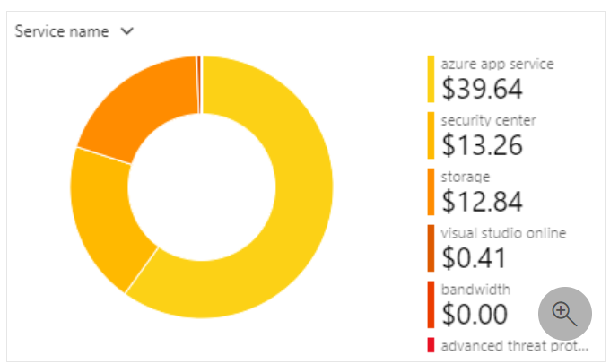

Apply tags to identify cost owners
Tags help you manage costs associated with the different groups of Azure products and resources. You can apply tags to groups of Azure resources to organize billing data.
For example, if you run several VMs for different teams, you can use tags to categorize costs by department, such as Human Resources, Marketing, or Finance, or by environment, such as Test or Production.
Tags make it easier to identify groups that generate the biggest Azure costs, which can help you adjust your spending accordingly.
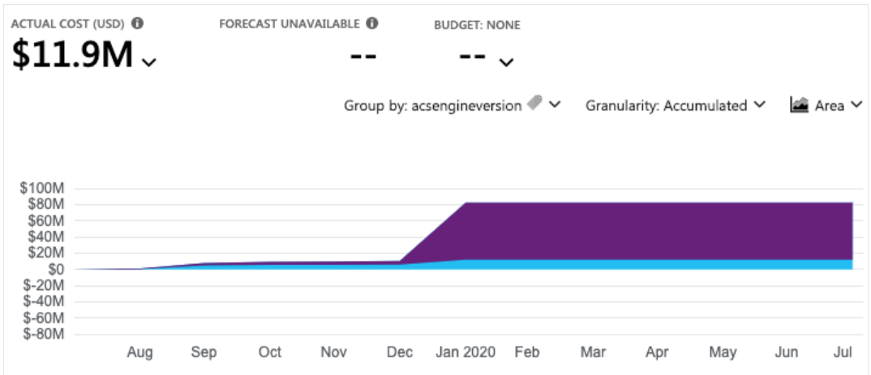

Resize underutilized virtual machines
A common recommendation that you'll find from Azure Cost Management + Billing and Azure Advisor is to resize or shut down VMs that are underutilized or idle.
Virtual machine costs are linear and double for each size larger in the same series. So in this case, if you reduce the VM's size from Standard_D4_v4 to Standard_D2_v4, which is the next size lower, you reduce your compute cost by 50 percent.

Deallocate virtual machines during off hours
Recall that to deallocate a VM means to no longer run the VM, but preserve the associated hard disks and data in Azure.
If you have VM workloads that are only used during certain periods, but you're running them every hour of every day, you're wasting money. These VMs are great candidates to shut down when not in use and start back when you need them, saving you compute costs while the VM is deallocated.
This approach is an excellent strategy for development and testing environments, where the VMs are needed only during business hours. Azure even provides a way to automatically start and stop your VMs on a schedule.

Delete unused resources

Migrate from IaaS to PaaS services
As you move your workloads to the cloud, a natural evolution is to start with infrastructure as a service (IaaS) services because they map more directly to concepts and operations you're already familiar with.
Over time, one way to reduce costs is to gradually move IaaS workloads to run on platform as a service (PaaS) services. While you can think of IaaS as direct access to compute infrastructure, PaaS provides ready-made development and deployment environments that are managed for you.

Save on licensing costs

Choose cost-effective operating systems

Use Azure Hybrid Benefit to repurpose software licenses on Azure

